**A Report submitted in partial fulfilment of the regulations governing the award of the Degree of BSc (Honours) Computer Science at the University of Northumbria at**

**Newcastle**

**Project Report**

**A performance comparison of parallel and sequential systems for big data**

**analysis**

**Sarah Nightingale**

**2015/2016**

**General Computing Project**

## Authorship Declaration

I declare the following:

(1) that the material contained in this dissertation is the end result of my own work and that due acknowledgement has been given in the bibliography and references to ALL sources be they printed, electronic or personal.

(2) the Word Count of this Dissertation is ...................................

(3) that unless this dissertation has been confirmed as confidential, I agree to an entire electronic copy or sections of the dissertation to being placed on the eLearning Portal (Blackboard), if deemed appropriate, to allow future students the opportunity to see examples of past dissertations. I understand that if displayed on eLearning Portal it would be made available for no longer than five years and that students would be able to print off copies or download.

(4) I agree to my dissertation being submitted to a plagiarism detection service, where it will be stored in a database and compared against work submitted from this or any other School or from other institutions using the service.

In the event of the service detecting a high degree of similarity between content within the service this will be reported back to my supervisor and second marker, who may decide to undertake further investigation that may ultimately lead to disciplinary actions, should instances of plagiarism be detected.

(5) I have read the Northumbria University/Engineering and Environment Policy Statement on Ethics in Research and Consultancy and I confirm that ethical issues have been considered, evaluated and appropriately addressed in this research.

SIGNED:

## Acknowledgements

I would like to thank my supervisor David Kendall, for his continued advice and support throughout this project.

I would also like to thank Kezia Rapley for proof reading this project and identifying formatting issues.

Table of Contents

Authorship Declaration 2

Acknowledgements 3

1. Abstract 6

2. Introduction 7

2.1. Background to Big Data 7

2.2. Plan of Work 8

3. Big Data and Parallel Processing 9

3.1 Types of Database 9

3.2 Big Data and Data Mining 10

3.3 Data Mining Algorithms 11

3.4 Naïve Bayes Classifier 13

3.6 Summary of Current Systems 14

3.7 Summarisation of the review of relevant literature 17

4. Resources and Implementations 18

4.1 Required Resources 18

4.2 Datasets Used 18

4.3 Requirements 19

4.4 Implementation of Standalone Naïve Bayes 20

4.5 Implementation of Spark Naïve Bayes 24

4.6 Dataset Manipulator 30

4.7 Prediction and Accuracy Checker 33

4.8 Product Testing 35

5. Comparing Standalone and Spark Naïve Bayes 38

5.1 Running the tests 39

5.2 Performance Test Results 41

5.3 Analysis of Test Results 44

5.4 Comparison of the two solutions 46

6. Evaluation of the Work Done and the Project Process 49

6.1 Evaluation of work done 49

6.2 Evaluation of project process 50

7. Conclusions and Suggestions for further research 53

7.1 Conclusions 53

8. References 56

9. Appendices 59

9.1 Appendix 1 – Terms of Reference 59

9.2 Appendix 2 – Standalone Naïve Bayes algorithm 65

9.3 Appendix 3 – Spark Naïve Bayes algorithm 69

9.4 Appendix 4 – Dataset Manipulator Script 70

9.5 Appendix 5 – Prediction and Accuracy Checker script 71

9.6 Appendix 6 – Dataset Manipulator test results on the small dataset 74

9.7 Appendix 7 – Prediction and Accuracy Checker Results 75

9.8 Appendix 8 – White Box test results on standalone Naïve Bayes 76

## 1. Abstract

Big Data is an ever expanding, and increasingly important field within the Computing world. With the current rate of data expansion - doubling how much data is stored every two years - it is becoming ever more important to find new, effective ways of analysing and using this data. This project will aim to investigate one solution to analysing this data, using a Naïve Bayes Classifier implemented in parallel using Apache Spark’s MLlib libraries, and comparing this to a standalone equivalent running sequentially.

These Naïve Bayes Classifiers will both be used to analyse varying amounts of identical numerical data, categorising these into the appropriate categories. They will both be tested on small, medium and large amounts of data, to show the impact the size of data has on the run time and accuracy of each solution. The Apache Spark implementation of the classifier is expected to show some improvement in handling this data as the amount of data increases, whereas the sequential standalone implementation is expected to become slower and less accurate as it is given larger amounts of data.

The overall aim of the project is to compare the functionality of an algorithm implemented with Apache Spark, with an equivalent standalone algorithm, identifying features which make Apache Spark a more effective system for big data analysis. The comparison will look in detail into comparing the overall performance, ease of use, methods of data processing and how failure tolerant each of these solutions are.

To test these theories and make a comparison, a Naïve Bayes classifier was implemented using Apache Spark’s MLlib libraries and another implemented standalone using the Python programming language. They were then run using three datasets of varying sizes, and the average run time and accuracy on each dataset was then compared. The results from these tests showed that a standalone solution to Naïve Bayes was more accurate and better suited to small to medium sized datasets, whereas a Spark solution was more effective in big data analysis.

Further work could be done in this area to improve the similarity between the underlying calculations of both solutions, as this had an effect on the final results and further improvement here would help to validate the results found.

## 2. Introduction

### 2.1. Background to Big Data

Big Data is an ever expanding and increasingly important field within the Computing world. With the current rate of data expansion, it is becoming ever important to find new, more efficient ways of analysing this data.

The definition of big data covers a multitude of different data types, ranging from digital data, to data on health, to historical data (Maycotte, Umbel, and Contributors, 2016). Its extreme size leads to the term ‘big’ data, as it is no longer containable or feasible to analyse it in traditional methods, such as in an Excel spreadsheet. Nowadays, the amount of data produced is measured in zettabytes, with this amount almost doubling every two years. (Fan and Bifet, 2012). Each of type of data within the term big data is necessary in some form, and in order to be fully utilised requires analysing to produce the information required.

Information is generally gathered from data using a technique called Data Mining; this is the process of analysing and manipulating the raw data in order to gather useful information from it, such as patterns in peoples spending habits or lifestyle choices that lead to illnesses. (Palace, 1996). How data mining is done has needed to change drastically over the past 20 years in order to keep up with this influx in data.

Often used in the analysis of big data sets are open source solutions, such as Hadoop’s MapReduce and Apache Spark. These solutions offer a way to store, and process these extreme amounts of data in a far more practical and efficient way than traditional methods.

This report aims to investigate the reasons for using these solutions over traditional methods of analysing data, in this case specifically focusing on the benefits of using Apache Spark on large datasets. The features offered by this solution will be investigated and considerations made for why these features are making software such as Apache’s Spark, such popular and widely used solutions for big data analysis.

Benchmarking tests will be used to compare the run time and accuracy of a solution implemented using Apache Spark, and a standalone solution running sequentially. These results will then help form a conclusion on when to use traditional data analysis methods and when to use a solution created with software such as Spark.

### 2.2. Plan of Work

The proposed work for this project is to implement a machine learning algorithm into Apache Spark and standalone using the Python programming language, both being hosted on a virtual machine. These solutions will then be tested using three datasets of varying sizes, gathering the speed of the tests and the average time taken for the data to be analysed. These benchmarking results will then be used to consider the impact the size of the dataset has upon the run time and accuracy of the solutions, and will be used to investigate the overall performance, ease of use, failure tolerance and the individual methods of data processing of each solution.

This project will not be able to look into extreme sized datasets and will be focused on the smaller side of big data. This is due to limitations of resources, and a lack of time to spend running the standalone solution on such large data, as this can take days.

The results of this project will help to provide insight into when it is reasonable to use each solution, and the advantages and disadvantages of using each solution on datasets of differing sizes.

## 3. Big Data and Parallel Processing

As this project aims to make a comparison between Apache Spark and a standalone version of the same algorithm, this review of relevant literature will be used to investigate the ways both of these pieces of software have been used in the past, and take into consideration the types of data they have been used to analyse. This will help to ensure all previous research is considered, the results of which can be used to enhance this report. Without the use of previous research done in this area this report will not be able to make a valid comparison, so any data gathered during this literature review must be wholly considered and brought forward into the final comparison. Areas which will be investigated in this review will cover big data, current methods of data mining and solutions for implementing parallel processing of big data sets. This will help to identify key areas for consideration within this comparison between sequential and parallel methods of data mining.

### 3.1 Types of Database

Traditional databases, such as relational databases, struggle to analyse such large amounts of data as they cannot effectively scale to meet the required storage sizes, and cannot handle such varied data types.

One reason for this is that relational databases are very strictly structured, with all the data being stored in columns and rows, with each column containing a certain datatype. Relational databases can allow for Referential Integrity, as tables are related to each other using a combination of primary and foreign keys. This is important in maintaining the validity of the data in this kind of database. In non-relational databases however the schema is so flexible that there is no such thing as the referential integrity that occurs in relational databases. In these kinds of databases, the data does not require JOINs between objects as it is highly de-normalised. One of the most popular emerging non-relational databases is called NoSQL (Not only SQL). This is based upon the BASE system, BASE standing for ‘Basically Available, Soft-state, Eventually consistent’, rather than the ACID system used in relational databases, which stands for ‘Atomicity, Consistency, Isolation, Durability’.

The ACID system currently in use in relational databases offers valuable functions for smaller databases, however offers little functionality in databases containing vast amounts of data. This is due to the way the ACID system ensures consistent data, as using this method an exact representation of data is shown at all times. This is done by locking parts of the database while changes are made to the data, and only unlocking them once the change is complete and the data can be updated. (D.Cook, 2009) This works well in a small dataset where the data is accessed less often and only one change is being made at a time, however in large datasets this becomes impractical as the data is constantly being updated in various places at the same time, making it almost impossible to lock down sections of the database while data is updated. In cases such as these it becomes more viable to use snapshots of the dataset, giving an approximation of the data which can be updated at various intervals. This is the method taken by the BASE system, which only requires the data to be consistent eventually, rather than after each database transaction. This method is commonly used by large online retailers where it is better to give an approximate on how many items are in stock, than to make each customer wait until the customer purchasing the item before them is complete.

### 3.2 Big Data and Data Mining

*‘It’s not easy to measure the total volume of data stored electronically, but an IDC estimate put the size of the “digital universe” at 0.18 zettabytes in 2006 and is forecasting a tenfold growth by 2011 to 1.8 zettabytes. A zettabyte is 1021 bytes, or equivalently one thousand Exabyte’s, one million petabytes, or one billion terabytes. That’s roughly the same order of magnitude as one disk drive for every person in the world.’* – Tom White

Big Data can be described as data that is too big, too varied, or too quickly evolving to fit into the constraints of a regular databases architecture (Trnka, 2014). However, there is no set definition of what is considered big data. As technologies advance and new software is developed what may have today been considered ‘big data’ may soon become easier to deal with and new, even larger and more unordered data sets will take over as the new ‘big data’.

With the current increases in data sizes, at a rate of 50% more data being created each year (Lohr, 2014), and heavier dependability from society on information from such data, reliable methods must be found to analyse this data successfully, and gather the information we require from it.

Big Data can be gathered from a multitude of different sources and is embedded in every part of modern day society. As quoted by McKinsey Global Institute, *“Big data—large pools of data that can be captured, communicated, aggregated, stored, and analyzed—is now part of every sector and function of the global economy”* (McKinsey Institute, 2011). With the development of Smart technologies and Smart Cities the amount of diverse data being gathered is only set to increase, growing in both size, and variety.

Without being able to successfully analyse this data and draw information from it, all of this data is useless at it means nothing in its raw format. In order to gather this information from the data, a technique known as data mining can be used.

Data Mining (also known as data discovery) is the process of gathering and analysing previously unknown information from sources of data for practical uses, whether they be financial, or otherwise used in society. (Witten, 2005) It is often related to finding correlations within large amounts of data. Data mining has the power to harness the data gathered and put it to its full potential.

Data Mining was first deemed to be an important area of further research in the early 1990’s, being extensively discussed at the IJCAI-89 Workshop, where it was concluded that the time for advancing knowledge discovery had come (Piatetsky-Shapiro, 1996). Around that same time, other researchers, such as Jiawei Han of the University of Illinois, were also beginning to look into and understand the importance of Data Mining. *‘Every enterprise benefits from collecting and analysing its data: hospitals can spot trends and anomalies in their patient records, search engines can do better ranking and ad placement, and environmental and public health agencies can spot abnormalities in their data’* (Han, 1996).

Nowadays, one way that data mining is often used is for marketing purposes, with companies such as Amazon storing data on each customer’s spending patterns, and which items their customers are looking at or have previously purchased. They can then use this data to advertise similar products to the customer in an attempt to drive up their profits. It also allows the companies to send targeted promotions, and shows them which items are currently popular, or are predicted to become popular and make warehouse adjustments accordingly. When data mining is used effectively and to its full potential it can create a multitude of opportunities for businesses, and is therefore a powerful tool, not just in modern day commercialism, but also in other fields. (Fayyad, Piatetsky-Shapiro, and Smyth, 1996)

### 3.3 Data Mining Algorithms

Data Mining can be performed by a number of different techniques and algorithms, all completing different tasks and drawing information from the data in different ways. One of the most popular methods of data mining is the use of machine learning algorithms to interpret and classify the data (Becker, 2002).

A main consideration when deciding to use a data mining approach is which algorithm would be the most appropriate for the data being analysed, and the information that is needed to be interpreted. In 2006 the IEEE International Conference on Data Mining identified ‘the top 10 algorithms in data mining’. As found by them, the top data mining algorithms of the time were C4.5, the k-means algorithm, support vector machines, the Apriori algorithm, the EM algorithm, PageRank, AdaBoost, kNN: k-nearest neighbour classification, Naïve Bayes, and CART algorithms. All of these algorithms are still highly relevant in data mining and machine learning and form a good starting point for the selection of a relevant algorithm for use in the comparison between standalone and parallel data analysis.

C4.5 was rated the number one algorithm according to the IEEE International Conference on Data Mining. It is an algorithm used for building decision trees from a set of training data, using the concept of information entropy. It was developed by Ross Quinlan in 1978 and is used on classification tasks where the data to be analysed is in the form of a flat file, meaning the data is stored entirely on the host computer and must be read into the computer’s memory in order to access the data and manipulate it. (Quinlan, 1999). This restraint on datatype means that this algorithm is not particularly well suited to Big Data analysis, as a flat file database is generally small and simplistic, and would not be able to store the required big data sets.

Similar to C4.5 in the way that it takes the format of a decision tree is the CART algorithm, which is based on Classification and Regression Trees by Breiman (1984). A CART tree is similar to a decision tree in that it consists of a root node and child nodes. In a CART tree, the child nodes are constructed by repeatedly splitting the root node into two, with the root node containing the entire data sample. (CART Algorithm, no date)

CART differs from C4.5 in that tests in CART are always binary, however tests in C4.5 allow for two or more outcomes. Both C4.5 and CART algorithms are not ideal for use with Big Data, due to the fact that decision trees become much more complex and difficult to understand with larger datasets. Regular pruning of these trees would be required to remove unnecessary data, and without this the predictions would become more and more inaccurate. C4.5 uses a method called pessimistic pruning. This is a fast method of pruning and helps to maintain efficient trees, however as this method uses an estimate value of each node it is not the soundest option and can lead to some errors in final analyses done using this technique. (Hall et al, no date)

Another algorithm feature in the top 10 by the IEEE is the k-means algorithm. This algorithm was designed and developed by a number of researchers, the main ones being Lloyd (1957, 1982), Forgey (1965), Friedman and Rubin (1967), and McQueen (1967).

The K-means algorithm is a clustering algorithm, with K standing for the number of clusters which the user inputs to the algorithm. K-means attempts to classify numerical data points or observations into K-clusters. (Jain, 2010). Another algorithm loosely linked to the K-means algorithm is the K-nearest neighbour classifier. This comes in at number 8 in the top 10 data mining algorithms and is used for classification and regression. K nearest neighbour or k-NN is one of the simplest machine learning algorithms and is a type of instance-based learning. This is a kind of ‘lazy learning’, where the algorithm compares the new instances to ones that it has already been trained using, and has stored in memory. This type of learning makes the algorithm easy to train and adapt, as in order to classify new types of data, it need only be given similar types of data to store that it can compare with. (Henley and Hand, 1996)

Rated at number 3 in the list are Support vector machines. This is considered by the International Conference on Data Mining as ‘*one of the most robust and accurate methods among all well-known algorithms’*. A support vector machine - also known as an SVM - is a supervised learning model which performs classification and regression analysis. An SVM takes a set of training examples and builds a model from them, assigning new examples into one category or another. This makes this algorithm a non-probabilistic linear classifier.

At number 9 in the list is Naïve Bayes. Naïve Bayes is a statistical method for classification and can be used to solve diagnostic and predictive problems. It is a supervised learning algorithm that makes decisions based on the outcome of training data which it has been given. Naive Bayes has the ability to learn from stored data and can therefore make highly dependable and accurate decisions. It is also very quick to learn as with one pass over the data it can utilise that information.

Naïve Bayes will be the algorithm used to test the functionality of Apache Spark and Map reduce in this project, as it is a highly popular algorithm in data mining, and is ‘*simplistic, elegant and robust’* (Jain, 2010). Claims that Naïve Bayes Classifiers struggle to maintain accuracy when used on larger scales of data have been made, in a paper written by Kohavi, which looks into the accuracy of scaling up Naïve Bayes Classifiers. (Kohavi, no date) This will be something that will inadvertently be investigated during testing using this algorithm and will need to be considered when looking into the final results.

### 3.4 Naïve Bayes Classifier

Naïve Bayes Classifier is based on Bayes Theorem:

**P(h|D) = P(D|h) * P(h) / P(D)**

P(h) = prior probability of hypothesis h

P(D) = prior probability of training data D

P(h|D) = probability of h given D

P(D|h) = probability of D given h

Naïve Bayes uses conditional probability, or the probability that A will occur given B, to calculate the probability of a specific outcome. (Puga, Krzywinski, and Altman, 2015). It was named after Thomas Bayes who proposed the initial Bayes Theorem, upon which this approach is based. Naïve Bayes is often used in word classification, and in things such as spam email detection. Naïve Bayes - also known as idiot Bayes - uses the assumption that all the features are conditionally independent given the class label. (Sebe, Lew, and Huang, 2004)

Naïve Bayes utilises a Supervised Learning method, this entails using training data to teach the algorithm, allowing it to make predictions on class labels for the new unseen data in a rational manner. A Naïve Bayes Classifier uses prior probability to determine its result, this is because it uses any prior knowledge that it has, and doesn’t take into account any of the observed data (Lewis, 1998). This means that if 99% of the data states one thing and only 1% states the other, the system will assume any new data fits into the 99% category with a 0.01 probability of error.

Naïve Bayes remains one of the most relevant and preferred algorithms for use in machine learning, as can be shown by its consistent inclusion in literature in this field, spanning from its conception in the 1950’s up until today, with papers such as ‘[Risk classification with an adaptive Naive Bayes kernel machine model](http://www.tandfonline.com/doi/abs/10.1080/01621459.2014.908778) – J Minnier, M Yuan et al’ and others of a similar topic having been written in the past year (Minnier, 2015). Naïve Bayes also remains more popular than boosted trees, Support Vector Machines and Max Entropy as while it can often be out performed by these techniques it is also much less computationally intensive and it requires a much smaller amount of training data. Another benefit Naïve Bayes has over these techniques is that it can learn its training data in a significantly smaller amount of time, making it very efficient. This also makes it good for use in real time systems as there is very little delay whilst the system is trained. (Rish, 2001)

One type of Naïve Bayes is the Multinomial Naïve Bayes Classifier; this is a specific instance of a Naïve Bayes classifier which assumes a multinomial distribution for all of the pairs. This can be a rational assumption in some circumstances, for example for word counts in documents. Multinomial Naïve Bayes is often used for word frequency information in articles or news stories. (Metsis, Androutsopoulos, and Paliouras, no date)

Another well-known variation of Naïve Bayes is the Bernoulli model of Naïve Bayes. This is also most commonly used in text classification, however this method uses binary elements, using the value of 1 if an item is present in a text document, or 0 if the item is not present.

### 3.6 Summary of Current Systems

Parallel Processing is a method of processing in which multiple processes or programs are run at the same time, with the end goal of reducing the time taken to run the program. This is opposed to serial processing which is used on older computer systems, where each process was run one after another, leading to long processing times whilst waiting for the operations to complete.

Parallel processing has been able to advance further in the past couple of years, expanding from usage solely in advanced computer systems to now being used generally, thanks to the evolution of multi-core processors. Parallel processing has also advanced in an effort to minimise power consumption and heat generation

#### 3.6.1 Hadoop

When considering which pieces of software to use in relation to Big Data, the option that appears the most frequently is Hadoop. Hadoop was created by Doug Cutting and has its origins in Apache Nutch, a web search engine. It is an open source framework which is used for the distributed storage and distributed processing of extremely large data sets. According to the Hadoop website:

*‘The Apache Hadoop software library is a framework that allows for the distributed processing of large data sets across clusters of computers using simple programming models. It is designed to scale up from single servers to thousands of machines, each offering local computation and storage. Rather than rely on hardware to deliver high-availability, the library itself is designed to detect and handle failures at the application layer, so delivering a highly-available service on top of a cluster of computers, each of which may be prone to failures.’ (Welcome to ApacheTM Hadoop®!, 2014)*

Hadoop is an important piece of software for many reasons, the main one being its ability to store and process huge amounts of any kind of data. This is particularly important with Big Data and the Internet of things, as the data sets needing to be analysed may contain a large range of data types and a huge volume of data. Hadoop also possesses a large amount of computing power, with the processing power increasing as more nodes are added. One of the main benefits of using Hadoop in a Big Data scenario is the flexibility that it offers. Due to of the structure of the databases, there is no need to pre-process the data before it is stored. This is an advantage of Hadoop over relational databases as it allows you to store as much data as you choose to and then choose what you want to do with it later. Hadoop can also store the unstructured data that is associated with big data, it does this in a fairly inexpensive manner whereas storing this kind of data in a relational database would be very expensive. Another way Hadoop is a cost effective solution for handling Big Data is that it allows a system to grow freely and easily, requiring very little administration to do so. (Borthakur, 2007), (Bialecki 2005).

Hadoop currently consists of four core modules:

Hadoop Common – the basic libraries and utilities used by the other modules of Hadoop,

Hadoop Distributed File System – The file system used by Hadoop, which was specifically designed for MapReduce jobs which require large inputs and outputs. (Venner, 2009)

YARN (Yet Another Resource Negotiator) – the resource management handler for processes running on Hadoop,

MapReduce – A programming model used for processing large datasets on a cluster. Consists of a map method, which performs the sorting of the data, and a reduce method, which performs the action on the data. (Dean and Ghemawat, no date)

#### 3.6.2 MapReduce

MapReduce is one of the current pieces of available software for big data analysis. MapReduce was created to allow for the processing of very large data sets using a parallel, distributed algorithm on a cluster. It works by allowing the user to specify a map function and a reduce function. The map function is inputted a set of data, represented as key/value pairs, which it then processes accordingly to output a different set of key/value pairs. (Dean and Ghemawat, no date). The reduce function performs a summary operation, such as merging all of the values associated with the key specified in the map function. The MapReduce function is automatically run in parallel, with the program being executable over a large cluster of machines (Dean and Ghemawat, 2010. The MapReduce run-time system handles all of the partitioning of the data, schedules the execution of the program across multiple machines, handles any failures that occur during execution, and deals with all inter machine communication. Due to this, the system is fairly easy to learn and use and programmers without much knowledge or experience of large distributed systems can still utilise all of the functions it offers.

#### 3.6.3 Apache Spark

According to the Apache Spark website “*Apache Spark™ is a fast and general engine for large-scale data processing.”* (Apache SparkTM - lightning-fast cluster computing, no date). Apache Spark was released on 30th May 2014 and was created at the University of California, Berkley before being donated to the Apache Software Foundation. Spark supports various programming languages, such as Java, Python and Scala.

Apache Spark was chosen for use in this comparison for a number of reasons. The first reason is that Apache Spark is a relative newcomer in the Big Data Analysis world but has quickly become one of the fastest and most reliable pieces of software. To investigate why this is, performance data will be used to give insight into the reasons behind the recent increase in its popularity.

One of the benefits of using Apache Spark is its ease of use and wide range of functionalities. Included in Apache Spark is MLlib; Spark’s own machine learning library. MLlib supports various different languages and features a variety of regression and classification algorithms such as K-means, Decision Trees, Linear Regression and Naïve Bayes. MLlib was developed as part of the MLbase project in 2012 and was packaged and released with Spark in 2013, it now has over 140 contributors from over 50 organisations (Meng et al., no date). Previous testing has been done on the performance of algorithms when implemented in Apache Spark’s MLlib compared with Apache Mahout running on Hadoop’s MapReduce by Xiangrui Meng et al in 2014. This found that the MLlib implementations were much faster, finding that ‘*MapReduce’s scheduling overhead and lack of support for iterative computation substantially slow down its performance on moderately sized datasets.’* As this performance test was done on version 1.4 of Apache Spark, this may not fully reflect the current performance of the MLlib functions, therefore this project will aim to continue this research using the current version of Apache Spark which is 1.5.1.

3.6.4 Resilient Distributed Datasets

Resilient Distributed Datasets, also known as RDD’s, are distributed collections of items and are the main data abstraction in Apache Spark. The formal definition of them, taken from the paper ‘Resilient Distributed Datasets: A Fault-Tolerant Abstraction for In-Memory Cluster Computing’ by the creators of RDD’s and Apache Spark Matei Zaharia et al, states that they are *‘a read-only, partitioned collection of records.’*

RDD’s are known as being resilient as they offer the ability to be fault tolerant, and are therefore able to recompute any missing or damaged partitions in the data. (Gopalani and Arora, 2015). The name ‘Distributed’ comes from their ability to be used across clusters and be processed in parallel.

An RDD is able to support two types of operations, transformations and actions. A transformation is used for creating a new dataset from an already existing one. For example, the map transformation, which passes the contents of a dataset to a function, and then returns a new dataset based on the results. All transformations done in Spark are known as being lazy, this is due to them not computing their results immediately, instead remembering the transformations which have been applied and only computing them when an action requires them to be returned to the driver program. This helps to increase the efficiency of Spark. Another feature designed to increase efficiency of Spark and its use of RDD’s is the ability to persist an RDD in memory. This keeps the data around on the cluster, allowing much faster access the next time the data is required. (Karau et al., 2015)

An action is used for ‘returning a value to the driver program after running a computation on the dataset.’ (Spark programming guide). An example of an action supported by Spark is the count() action. This action will return the number of elements in a dataset. It also supports the saveAsTextFile() action, which will write the elements of a dataset to a text file in any given local directory.

3.7 Summarisation of the review of relevant literature

Many of the findings made during this review of relevant literature can be taken forward to be used and consulted during the implementation of this solution.

One major decision made during this analysis was to focus the project on the performance of Apache Spark, and not on Hadoop’s MapReduce. This decision was made upon the discovery that Hadoop’s MapReduce had already been the subject of many similar studies, and therefore yet more conclusions regarding this piece of software would not benefit the wider field of study as much as would be liked. In contrast to this, it was discovered that Apache Spark and its MLlib libraries were a relative newcomer in this field, and therefore research into this area would be of more gain.

The choice to use a Naïve Bayes algorithm as the implemented Machine Learning algorithm in this study was also made due to research conducted in this chapter. This algorithm was chosen due to its popularity, relevancy, and because it featured in the MLlib libraries available on Apache Spark.

## 4. Resources and Implementations

### 4.1 Required Resources

In order to implement the required tests a number of resources will be needed.

One consideration for this project was on what machine or environment to run the performance tests. The tests would require a machine that allowed for the installation of the Spark software on, however did not also have a large amount of other software installed on the machine, as these other pieces of software could have an impact on the run time of the tests. It was initially considered enough to use a real Linux machine, located in one of the computer labs at Northumbria University. This however, was found to be impractical due to the fact that any student would have the ability to install any software on the machines, making it impossible to keep track of any extraneous changes being made to the environment.

Another possibility, and the one that was the most viable for this project, was to set up a virtual machine on one real machine. This would be used to install all of the software onto and then to run each of the algorithms in their environments. In order to do this software such as VirtualBox, VMware, or Parallels would be needed. As VirtualBox offers a large number of features and is free to use this will most likely be the software used to implement this VM.

It was decided to use Ubuntu 14.0 as the Operating System for each of the Virtual Machines; this was because a Linux machine was required for all of the software needed, and due to previous knowledge of Linux commands, and familiarity with this operating system.

### 

### 4.2 Datasets Used

In order to test the scalability of both implementations three datasets of varying sizes will be required. The first dataset chosen was the smallest dataset, this is the dataset provided by Spark to test a Naïve Bayes algorithm on. This dataset consists of 12 rows and 4 columns of integers which can be classified into 5 different categories. The data is separated by commas which are stripped from the dataset before splitting each column into individual integers.

The middle sized dataset that will be used is the ‘Pima Indians Diabetes dataset’ (UCI Machine Learning Repository, 1990). This dataset is 768 rows and has 8 attributes. Each row of data in the set can be categorised as either 0 or 1, representing whether or not the patient in question shows signs of diabetes. The distribution of the categories in the dataset are 500 members of the ‘0’ category and 268 members of the ‘1’ category. This dataset is also separated by commas which must be stripped before appending each individual value to an array for use. This dataset consists of a combination of both integers and floats so this must be taken into consideration when handling the data.

The largest dataset to be used is the ‘Statlog (Landsat Satellite) data set’. This dataset consists of 6435 instances, each with 36 attributes, however for these tests a sample of 2000 instances of this dataset will be used. This is due to the fact that the dataset contains so many attributes that it is already a much larger sample of data than the other two sets. The dataset can be classified as 7 categories, ranging from 1 to 7 and representing the soil type, however within the sample of data given there are no examples of category 6. The dataset is made up of integers and is not missing any data.

These datasets were chosen because of their numerical data, and because none of these datasets are missing any values. This is due to the fact that were any of the datasets missing values it would have had an effect on the final predictions made, causing them to be incorrect. This would have impacted the final accuracy of the predictions and skewed the results of the Naïve Bayes algorithms.

Each of these datasets will be split by a 60/40 ratio for training and testing data. This will hope to ensure that the Naïve Bayes algorithm has enough sample data to train with, but not so much that it already knows the category that each attribute will be classed as.

### 4.3 Requirements

This project aims to compare the performances of two Naïve Bayes algorithms, one implemented in Apache Spark and one standalone implementation. Therefore, the first requirement for this project is to implement a working Naïve Bayes algorithm in Apache Spark. This will also require a method to time the algorithm and calculate how long it takes for it to complete.

In order to compare the performance results a standalone version of the Naïve Bayes algorithm must also be implemented. This will be used to compare with the Apache Spark version to show the difference in performance between the two. Again, this will require a method to time the running of the algorithm.

Since these performance tests rely so heavily on the Naïve Bayes algorithms being identical, an application must be created to compare the outputs of both of the algorithms. This will be written in Python and will need to take the values outputted by each algorithm from the output text files and compare them to see if the predictions made by the algorithms are the same.

In order to ensure that both algorithms are given the same training data and testing data, a separate application must be created to take each dataset, split it into individual attributes, shuffle the datasets to ensure the training data is representative of the whole dataset, and split the data into identical training and testing sets. This will then pass the training and testing sets to each algorithm which will be able to make identical predictions from this.

* Apache Spark implementation of Naïve Bayes.
* Standalone implementation of Naïve Bayes.
* Application to compare predictions of both algorithms.
* Application to shuffle and split dataset into appropriate training and testing data.

### 4.4 Implementation of Standalone Naïve Bayes

The standalone implementation of the Naïve Bayes Classifier was written in Python, this was due to prior knowledge of this language and the fact that its Apache Spark equivalent would also be supported in Python.

The implementation of this was based upon the Naïve Bayes formula which is: P(h|D) = P(D|h) * P(h) / P(D). In this equation a number of values are required from the data in order to make a prediction. The first of these required values is the Prior Probability of the prediction being true, this is represented by P(h). To gather this value, it was necessary to search through the training data and total up the number of times each category occurred. This was done in the function getCategories, as shown below:

*def getCategories(dataset,noOfAttributes):*

*i = 0*

*categories = []*

*while i < len(dataset):*

*categories.append(dataset[i, noOfAttributes])*

*i = i + 1*

*categories_set = set(categories)*

*categories = list(categories_set)*

*return categories*

This function is able to obtain the categories in the dataset by using the pre-determined variable noOfAttributes, which represents the final column of the dataset containing the category of that row of data. Each of the categories is then appended to the end of a Python list containing all of the categories found in the dataset.

The second value that is required is P(D), or the Prior Probability of attributes in the training data having occurred. This means how many times each attribute appears in a column of the training data, disregarding any of the other attributes or which category it is in. This can be calculated by counting how many times the attribute occurs, divided by the total number of rows in the training set. In the code this is calculated using the trainData function.

*def trainData(no_of_test, no_of_category, categories, totalTraining, trainingSet):*

*no_of_training = 0*

*no_of_attrib = 0*

*p_category = 0.0*

*num_category = 0*

*while no_of_training < totalTraining:*

*if categories[no_of_category] == trainingSet[no_of_training][no_of_attrib]:*

*num_category = num_category + 1*

*no_of_training = no_of_training + 1*

*else:*

*num_category = num_category + 0*

*no_of_training = no_of_training + 1*

*print 'category', categories[no_of_category], ':', num_category*

*p_category = float(num_category) / float(len(trainingSet))*

*no_of_attrib = no_of_attrib + 1*

*return p_category, num_category*

This function handles the training of the Naïve Bayes algorithm and calculates the Prior Probability of each attribute. It does this by checking each category from the Python list ‘categories’ against the column containing categories in the dataset. If these two match it then adds 1 to the variable num_category, which represents the total number of each category in the dataset. This is then used to calculate the prior probability, represented here by p_category, by dividing the total number of each category by the total length of the training set.

Also needed is the probability of h given D, this represents the probability of the category occurring based on the attribute in question. This can be found by counting the total number of a certain category occurring, and then counting how many times each attribute also occurs under that category. The total number of each attribute is then divided by the number of times that category occurs to give a value for P(D|h).

*def calculateProbability(no_of_test, testSet, no_of_attrib, noOfAttributes, trainingSet, p_category, num_category):*

*no_of_training = 0*

*count = []*

*i = 0*

*count.append(i)*

*while no_of_training < totalTraining:*

*if (np.all(testSet[no_of_test, no_of_attrib] == trainingSet[no_of_training, no_of_attrib]) & np.all(categories[no_of_category] == trainingSet[no_of_training, noOfAttributes])):*

*count[i] = count[i] + 1*

*no_of_training = no_of_training + 1*

*else:*

*no_of_training = no_of_training + 1*

*p_category *= float(count[i] + 3) / (float(num_category + 3))*

*print 'final', testSet[no_of_test, no_of_attrib], p_category*

This calculation is done in the calculateProbability function shown above. This function takes each piece of test data and compares each attribute in it to the attributes in the training set. It also checks each category against the category in the training set. If the attribute in the training and testing sets match, and the category matches with the category in the training set, then a value of 1 is added onto the value of count[i]. This totals up the number of times that the attribute in the test set is categorised as each category value in the training set. This information can then be used to make the final prediction of which category the test data would fit into.

The final calculation will work out how likely it is for the attributes in question to belong to each of the categories, from these outputs it will be seen which has the highest probability and therefore which category is predicted. This is called the posteriori probability of a hypothesis, h.

*p_category *= float(count[i] + 3) / (float(num_category + 3))*

This calculation represents P(h|D) = P(D|h) * P(h) / P(D). It uses all of the previously calculated values and does a Naïve Bayes calculation on them to give a final probability of each row of testing data belonging to a certain category. The actual calculation done multiplies the current value of p_category by the number of times the attribute in question was found to be categorised as the category in question, divided by the total number of this category in the training data. This is done repeatedly for each attribute in the row of test data until a final p_category is reached. This represents the likelihood of the test data belonging to the category it is being tested against.

One problem with the Naïve Bayes algorithm occurs when an attribute never arises in a certain category, this is known as Zero Frequency. This is a problem as the Naïve Bayes model will then assign a 0 probability and this makes it unable to make a prediction. In order to counter act this, a value of ‘m’ can be added to the equation to ensure that a zero value never transpires. This is done by changing the algorithm to P(h|D) = P(D|h) * P(h) + m / P(D) + m. The value of m is arbitrary; however, it must remain the same for all attributes in order for it to have no effect on the final prediction. In this scenario the value of m is set to 3 for each of the algorithms.

In order to work out which of the categories the Naïve Bayes algorithm believes the test data belongs in it is necessary to identify the largest value of P(h|D).

*result.append(p_category)*

*classificationVal = max(result)*

*classification = result.index(max(result))*

In this scenario this was done by appending each value of P(h|D) to the end of a Python list named ‘result’. This list holds each final value of p_category, allowing the largest value to be calculated for the final prediction. This was done by using the max method. This method returns the largest value found in a Python list, in this case result. Doing this then allowed the corresponding category to be found via the index method. This method found the position of the maximum value in the array which allowed it to be determined which category this value belonged to. This value could then be considered the predicted category and gave the final classification of the test data.

This process is repeated for each piece of test data, each time printing out the category predicted to a .txt file, appropriately named depending on the size of the dataset being categorised. Also printed out to the .txt file is the actual category that the test data belongs to, and the accuracy of the Naïve Bayes algorithms calculations.

The accuracy of the predictions is important to keep a record of as this is also a method of testing the Naive Bayes implementation to see that it is functioning correctly, and making reasonable predictions. A function is required within this script to calculate the accuracy of each prediction, checking the expected category against the predicted category from the Naïve Bayes algorithm.

*def getAccuracy(no_of_test, testSet, classifiction, accurate, k):*

*if (testSet[no_of_test,3] == classification):*

*accurate[k] = accurate[k] + 1*

*else:*

*accurate[k] = accurate[k] + 0*

*return accurate*

This is the getAccuracy function which updates the Python list ‘accurate’ for each prediction made. Each time the prediction made is equal to the actual category of the test data a value of 1 is added to the list. This list is then returned and for each piece of test data categorised it is updated. The value of this list is then used at the end of the Naïve Bayes algorithm to make a calculation showing the total accuracy of the predictions.

*totalAccuracy = float(accuracy[k]) / totalTest*

In order to calculate the accuracy of the algorithm the total number of correct predictions is divided by the total instances of test data. This gives the percentage accuracy of the algorithm which is then printed out to the .txt file with the results of the predictions.

### 4.5 Implementation of Spark Naïve Bayes

#### 4.5.1 Installation and Set-up of Apache Spark

In order to implement a fully functioning Naïve Bayes algorithm using the libraries made available in Apache Spark’s mllib, it was first required to download and install the latest version of Apache Spark, version 1.5.1. This download is available open source from the apache Spark website ([http://Spark.apache.org/](http://spark.apache.org/)). When selecting the download, it is possible to download either the source code, or a package including a pre-built version of Hadoop. In this case the version used was pre-built with version 2.6 or above of Hadoop, this is due to this being the latest version of Hadoop, and therefore the one that would be most relevant for testing upon.

The first step towards building a working Apache Spark was the initial set up of the Ubuntu Virtual machine that would be used for running the Apache Spark tests upon. In order to build and run version 1.5.1 of Apache Spark, version 3.0.0 or above of Maven is required, as well as Java 7+.

Installing Java on the Ubuntu machine was done via the command terminal, using the apt-get command. This command allows for the installation and updating of software packages, and is highly easy to use. It was decided to install and use Java Version 8, as this is the latest Java release, and would also be compatible with Apache Spark. The command used to install version 8 of Java, as required is:

*sudo apt-get install openjdk-8-jdk*

Once this command was run, version 8 of Java was successfully installed. This was confirmed by checking the installed version of Java on the virtual machine, using the command java -version as shown below:

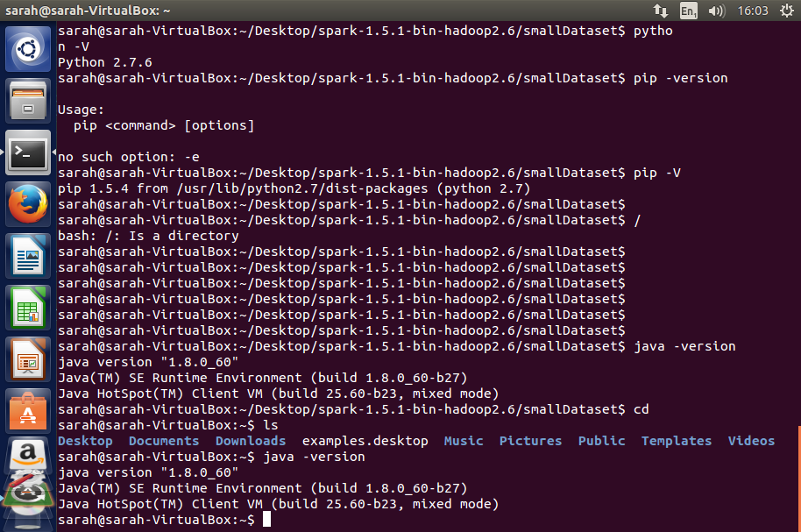

The next stage towards installing and building Apache Spark was installing the latest version of Maven onto the machine. This can be done via Spark itself, as Maven now comes pre-packaged within the build/ directory of Spark, however it was chosen to install Maven separately, due to the fact that the packaged version of Maven also came with Scala and Zinc, and neither of these pieces of software were required for the Python version of Apache Spark.

The version of Maven installed onto the virtual machine was version 3.0.5, as this was the latest version of Maven at the time. This distribution archive was downloaded from the Maven website (<https://maven.apache.org>). In order to install Maven, the JAVA_HOME environment variable was needed to be set, and needed to point to the installation destination of the JDK previously installed. This was done using the command:

*export JAVA_HOME=/usr/bin/JAVA/jdk1.8.0_60/*

Once this environment variable was set, the distribution archive of Maven could be unzipped into its destination directory. As the archive was in the format ‘.tar.gz,’ this was done using the command:

*tar xzvf apache-maven-3.0.5-bin.tar.gz*

The final stage was to add the new Maven directory to the end of the PATH environment variable, this was done using the command:

*PATH=$PATH:/apache-maven-3.0.5\bin*

Once the Maven directory was successfully appended to the PATH variable it was important to check the correct installation of Maven on the machine. This was done by firstly opening a new terminal, and then using the command mvn -v. The output displayed below shows that version 3.0.5 is successfully installed upon the virtual machine and ready to use.

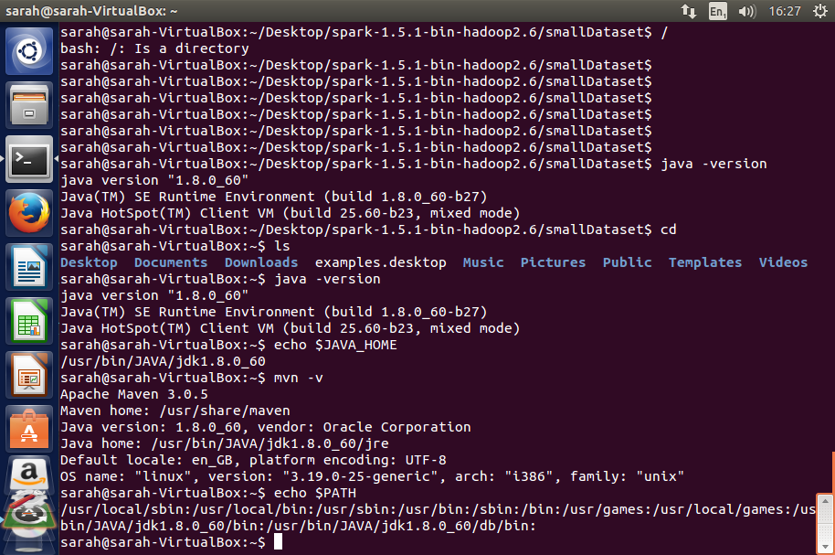

Once Java and Maven were correctly installed it was now possible to download and build version 1.5.1 of Apache Spark. The first step towards doing this was to unzip the archive file using:

*tar xzvf Spark-1.5.1-bin-hadoop2.6.tar.gz*

Once this folder was unzipped, the next stage was to navigate to the new Spark directory and run the command:

*./bin/pySpark*

As everything was installed correctly, this command started running the Python version of Apache Spark which was now ready to be used.

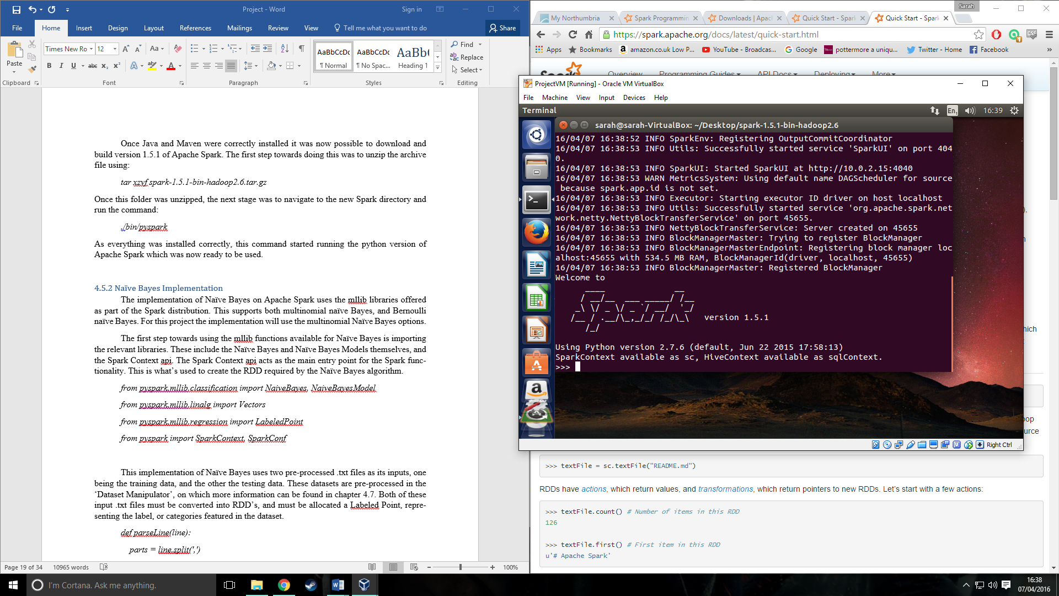

#### 4.5.2 Naïve Bayes Implementation

The implementation of Naïve Bayes on Apache Spark uses the mllib libraries offered as part of the Spark distribution. This supports both multinomial naïve Bayes, and Bernoulli naïve Bayes. For this project the implementation will use the multinomial Naïve Bayes options.

The first step towards using the mllib functions available for Naïve Bayes is importing the relevant libraries. These include the Naïve Bayes and Naïve Bayes Models themselves, and the Spark Context api. The Spark Context api acts as the main entry point for the Spark functionality. This is what is used to create the RDD required by the Naïve Bayes algorithm.

*from pySpark.mllib.classification import NaiveBayes, NaiveBayesModel*

*from pySpark.mllib.linalg import Vectors*

*from pySpark.mllib.regression import LabeledPoint*

*from pySpark import SparkContext, SparkConf*

This implementation of Naïve Bayes uses two pre-processed .txt files as its inputs, one being the training data and the other the testing data. These datasets are pre-processed in the ‘Dataset Manipulator’, on which more information can be found in chapter 4.7. Both of these input .txt files must be converted into RDD’s and must be allocated a Labeled Point, representing the label, or categories featured in the dataset.

*sc =SparkContext()*

*def parseLine(line):*

*parts = line.split(',')*

*features = Vectors.dense([float(x) for x in parts[0:7]])*

*label = float(parts[8])*

*return LabeledPoint(label, features)*

*training = sc.textFile('training.txt').map(parseLine)*

*test = sc.textFile('testing.txt').map(parseLine)*

In order to create the RDD’s for the testing and training data, the .txt files must be read into the script using SparkContext’s textFile method. This method is used for reading in a file from the local machine as a collection of lines. From here, the newly created RDD is transformed using the map transformation. The map transformation is used to pass an existing dataset, in this case the training and testing datasets, to a function, which will then return a new RDD containing the results of that transformation.

The function parseLine contains the separation of each item in the datasets, and locates both the features of the data, and the categories of it. It does this by firstly splitting the datasets by their delimiters, which in this case are commas. It next creates a local Vector of the features, or attributes found in the dataset. As shown in the code, the vector required is a dense vector. This is because of ‘parts’ being a Python list. In mllib two types of data are recognised as dense vectors, NumPy array’s and Python lists. The other alternative would be for the vector to be labelled as sparse, this includes the data types MLlib’s SparseVector and SciPy’s csc_matrix with a single column.

Shown above is an example from the medium sized dataset, meaning that the first 8 values of the dataset contain the features, upon which the Naïve Bayes algorithm must make its categorisation. The final column, column 9, represents the label, or classification of the data.

Once both the label, and features of the dataset have been obtained they can be returned as a LabeledPoint of the data. A labeled point is a local vector, and can either be dense or sparse. The values in the labelled point will be stored as doubles, due to the fact that they can be used in either classification, or regression algorithms.

Upon the creation of the training and testing RDD’s, the next step is to train the Naïve Bayes algorithm with the data held in the training RDD. This is made incredibly simple in Spark as this can be done in one line of code.

*model = NaiveBayes.train(training, 1.0)*

The above code uses the training RDD, now consisting of label and feature vectors and trains the Naïve Bayes model. It also takes a value for lambda, this acts as the smoothing parameter for the Naïve Bayes algorithm, ensuring that none of the calculations done result in a zero value as this would affect the end predictions. For these tests the value of lambda is left at its default of 1.0.

From here, the trained Naïve Bayes model can then be used to make predictions. This can also be done very simply, using one line of code:

*predictionAndLabel = test.map(lambda p : (model.predict(p.features), p.label))*

This piece of code again uses the map transformation on the data, however this time it is done solely on the test data set. The trained Naïve Bayes model, represented here as model, has the method predict. Predict is used to return the most likely class for the data vector to be classified as. This is done for each instance in the test RDD and a prediction is made for every feature, based on the training data passed into the Naïve Bayes model. These predictions are then used to create an RDD called predictionAndLabel. This RDD holds each predicted classification for the test RDD, and the actual classification which was stored in the initial test data set.

Next, the accuracy of the predictions was calculated. This was to help show how effective the Spark implementation of Naïve Bayes is to making accurate predictions, and helps to show that the implementation is functioning correctly. The following code shows this calculation:

*accuracy = 1.0 * predictionAndLabel.filter(lambda (x, v): x == v).count() / test.count()*

The accuracy of the predictions is calculated using the predictionAndLabel RDD, containing all predictions made, and the correct label for each instance of data. The filter transformation is used on this data set. This returns a new dataset which is created by selecting the elements of the dataset which return the value True. In this case a value of True is returned when the value of the prediction made, represented here as x, is equal to the value of the label, represented as v. The action count() is then performed on this dataset, giving the total number of instances where the prediction and the label are the same. The value of count can then be divided by the total number of instances in the test set, found by performing the count() action on the test data set, to give the percentage accuracy of the predictions.

In order to save the output of each run of the Naïve Bayes classifier, the predictionAndLabel dataset was printed out to an external .txt file. This was done to help during the testing of the algorithm and to check the overall accuracy. RDD’s come with a built in method for saving the data to a text file, this method was implemented in this code and is shown below:

*predictionAndLabel.coalesce(1).saveAsTextFile("./Prediction")*

The saveAsTextFile action takes each element in the RDD and writes them to a file, one element per line. The number of output files is equal to the number of partitions in the RDD being written out. In the case of this output it was required that the data only be outputted to one file, so it could be further analysed. To achieve this the function coalesce() was called before saving the data to the file. This transformation decreases the number of partitions to the number specified, in this case 1.

To execute this script with Spark, it must be run using a Python interpreter which is configured to run Python applications. In order to use this the PySpark script must be run along with the Naïve Bayes script. To run the Naïve Bayes algorithm in this instance the following command is used:

*.././bin/Spark-submit --master local[4] NaiveBayes.py*

This command does a number of things, including running the Naïve Bayes script. Firstly, it navigates to the directory containing PySpark, which it then runs. This creates the SparkContext which is used within the script. Next, the code is set to run locally on four cores. This is done by setting the –master environment variable and ensures that the code will be run in parallel. Finally, the Naïve Bayes script is run which will begin making predictions on the chosen dataset.

The end result of this code creates a folder within the specified directory called ‘Prediction’. Within this the text file containing the results is stored as the name ‘part-00000’, due to it being the first, and only, partition. Below is an example of the file part-0000 from an execution on the large dataset. Displayed on the left are the predictions made by the Naïve Bayes algorithm, and on the right are the correct labels given in the original dataset.

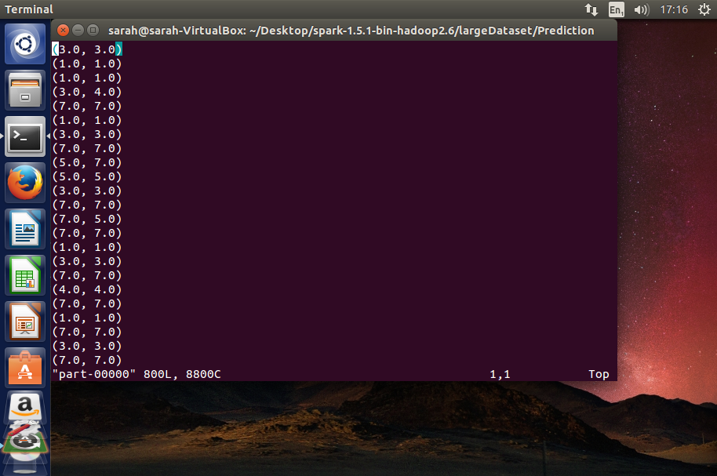

#### 4.5.3 Issues

One problem that was encountered during the implementation of this algorithm was the shuffling of the data, and how to pass both Naïve Bayes classifiers the same training and testing data. This was mainly an issue in the Spark implementation as Spark recommends using the transformation randomSplit on the dataset to create the training and testing data. The randomSplit function takes the dataset, a weight for the split, and a random seed for the shuffle and randomly splits the data in an RDD. This function works well for creating well shuffled and randomised sets from the data, however it is impossible to control the shuffling of the data and ensure that it is kept the same order as in the standalone version. Due to this it was not viable to use this function for these tests.

This meant finding a different way of passing the dataset to the Spark Naïve Bayes, whilst ensuring that the data sets were identical to the ones being passed to the Standalone Bayes.

The first available option was to not shuffle the datasets at all, and just split the datasets equally within each algorithm. This would have ensured the training and testing sets remained identical throughout the testing, however it meant that the training data was only representing a very small proportion of the data sets, which didn’t include all of the categories and attributes as the data was too ordered. This ended up having a large effect on the predictions made, as many categories were not acknowledged, and it was therefore negatively impacting on the accuracy of both of the algorithms.

The second, and most viable option for solving this problem, was to shuffle and split the datasets in a separate Python script. This allowed the datasets to be randomly shuffled, ensuring that the training data was more representative of the spread of the data. It also ensured that identical training and testing sets were being passed into each algorithm as all of the data being used had been manipulated together. The method of doing such is discussed in chapter 4.6.

### 4.6 Dataset Manipulator

During the implementation of the accuracy and prediction checker it was noticed that the Apache Spark classifier and the standalone one both outputted different values, due to being given different training data and different testing sets. This made it difficult to ensure that both algorithms were doing the exact same thing with the data. In this scenario it was important to be able to confirm that both algorithms were identical as if this wasn’t the case then the final results and conclusions drawn could not be considered valid. In order to do this, it was determined that both algorithms needed to be given not only the exact same datasets, but the exact same training and testing sets to work with. It was decided that the best way to ensure that this was happening was to create an external script that would split the data into the training and testing sets, while still shuffling the data beforehand to ensure an even spread of the categories and attributes.

In order to do this each of the three datasets of varying sizes was read into a numpy array and separated by its delimiter into individual items. This was done using the numpy function genfromtxt.

*#Read in the file to an array*

*filename = 'pima-indians-diabetes.data.txt'*

*dataset = genfromtxt(filename, delimiter=',', dtype=float)*

This example is from the medium dataset and shows the file being read in as the datatype float, due to the data in the original dataset being floats. Both the small and the large datasets are read in as integers, due to the data contained in those datasets being integers.

One important step in creating training and testing data is shuffling the original dataset into a new, random order. This is to ensure that an even spread of data is given to the Naïve Bayes algorithm for it to learn from. If this was not done it could dramatically affect the predictions made by the algorithm as certain categories may never occur in the training data, therefore the algorithm would assume these categories didn’t exist and would never make predictions of these categories. The way this was done in this script was by using the numpy.random.shuffle function:

*numpy.random.shuffle(dataset)*

*print dataset*

The purpose of this function is to shuffle the entire dataset randomly. This means that each time the script is run a new order of data will be created, ensuring that the algorithms are always tested on different datasets and never on the same ones. The dataset is then printed to show the new order of the data.

Once the data is shuffled it is then required to be split up into training and testing sets. It was decided that this would be done at around a 60% training, 40% testing ratio. This was done to give the Naïve Bayes algorithm plenty of training data to learn, ensuring it had enough information to make accurate predictions, without giving it so much that it already knew the categories for all of the data.

*training, testing = dataset[:460,:], dataset[460:,:]*

Splitting the shuffled dataset was done by allocating the first 60% of data, in this case 460 rows, to the training set and the final 40%, or 308 rows, to the testing set. This line of code simply does this by setting ‘training’ to the first 460 instances of ‘dataset’, and then ‘testing’ to all instances after item 460.

The final part of this script is required only for the Apache Spark implementation of the Naïve Bayes algorithm. This is where the training and testing datasets are written out to separate .txt files named ‘training.txt’ and ‘testing.txt’. This was not required for the standalone version of Naïve Bayes as for that algorithm it is enough to import the variables ‘training’ and ‘testing’ from the script and then to use them from there. However due to the way Apache Spark functions, the input to the Spark Naïve Bayes needed to be an RDD (Resilient Distributed Dataset). The most common way of inputting a training and testing set to an Apache Spark implementation is to use a RDD transformation called randomSplit, the purpose of this being to split an RDD into two RDD’s whilst shuffling the data randomly. This however was not applicable to this implementation as the dataset was already shuffled and did not require to be further shuffled. In order to work around this and give the Spark mllib implementation the pre shuffled training and testing sets this solution was created.

*numpy.savetxt('training.txt', training, fmt='%1d', delimiter=',', newline='\n')*

*numpy.savetxt('testing.txt', testing, fmt='%1d', delimiter=',', newline='\n')*

These lines of code use the numpy function savetxt to save the contents of both the training numpy array, and the testing numpy array to txt files. The also replace the delimiters between the individual items in the dataset and re-format them back into the original formatting of the dataset. For example, a snippet from ‘testing.txt’:

*6,109,60,27,0,25,0,27,0*

*0,141,0,0,0,42,0,29,1*

*4,132,86,31,0,28,0,63,0*

*1,117,60,23,106,33,0,27,0*

*3,102,44,20,94,30,0,26,0*

In doing this, the Apache Spark implementation can then take the two .txt files and create the two required RDD’s from these using Spark functionality, whilst keeping the data in the same order as in the standalone Naïve Bayes.

Below is an example taken from running createDataset.py on the small dataset. The first image is the original dataset, which is shown in order of categories and attributes. The second image is the dataset once randomly shuffled, this is the data that is then inputted to the Naïve Bayes algorithms.

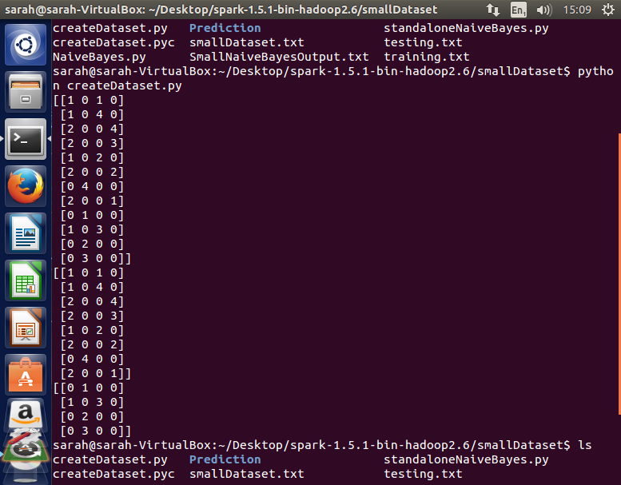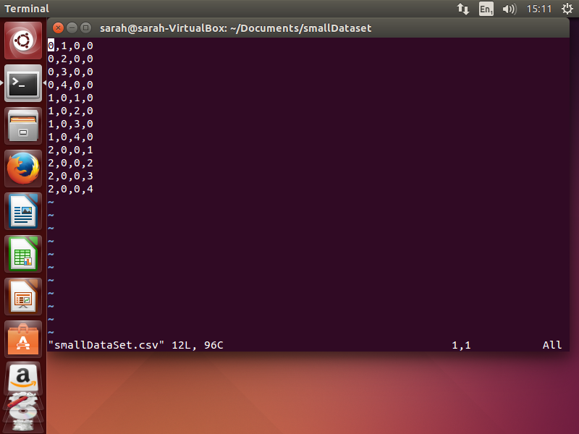

Image 2: Randomly Shuffled Dataset

Image 1: Original Dataset

### 4.7 Prediction and Accuracy Checker

In order to ensure that both implementations of the Naïve Bayes algorithm were functioning correctly, and were giving similar predictions based on the data given, it was important to check the outputs of both applications. This was done using a separate Python script that checked over the output .txt files from both Naïve Bayes algorithms.

This Python script was run after both the standalone and Spark implementations of the Bayes Classifier had been run on each identical set of data. It firstly read in the data contained in each output file, and stripped each line of any parenthesis and commas.

*with open(standaloneFilename) as f:*

*standalone = f.readlines()*

*standalone = ([i.strip('(), \n') for i in standalone])*

*standalone = ([i.replace(',', '') for i in standalone])*

This was done using both the strip, and replace methods and resulted in a Python list containing only the categories predicted by the Bayes Classifier, and the actual category for each piece of test data.

In the case of the standalone output, it was also necessary to remove the line which outputted the accuracy of the algorithms predictions, as this was not included in the Spark output file and would not be used during the comparison of results. This was done using:

*standalone.pop()*

This method removes the item at any given position in a list. By default, it removes the last item in the list, which was what was required to remove the line containing the average from the list.

This list of variables was then split further into one list containing predictions made, and one containing actual predictions. This was done using the split function:

*std1 = ([i.split(' ')[0] for i in standalone])*

*std2 = ([i.split(' ')[1] for i in standalone])*

Upon completion on both the Spark and standalone output files, this resulted in four Python lists, two containing predictions made and two containing actual predictions. The items in these lists could then be compared to see whether or not the two implementations of the algorithms were outputting the same, or similar predictions.

*while x < length:*

*if ((spk1[x] == std1[x]) & (spk2[x] == std2[x])):*

*match = True*

*same_prediction = same_prediction + 1*

*x = x + 1*

*else:*

*match = False*

*x = x + 1*

This code checks whether or not the categories predicted by the Bayes Classifiers matched. It does this by comparing each item in the arrays containing predictions (spk1, std1) and checking if these values are equal. It also confirms that the test data sets are the same by comparing the actual category values, contained in spk2 and std2. If each equality comparison is correct then the value of same_prediction is increased by one. This variable keeps track of how many same predictions were made by the algorithms, and is later used to calculate the number of same predictions made by both Bayes Classifiers.

The similarity of predictions made by each classifier is calculated using the value of same_prediction, and the length of the Spark list containing predictions.

*accuracy = float(same_prediction) / length*

This calculation gives the percentage of identical predictions and can be used to check whether or not the Naïve Bayes algorithms function in the same manner. This information is written out to a file, which also contains whether or not the algorithms made the same predictions for each piece of test data. An example of this output file is shown below:

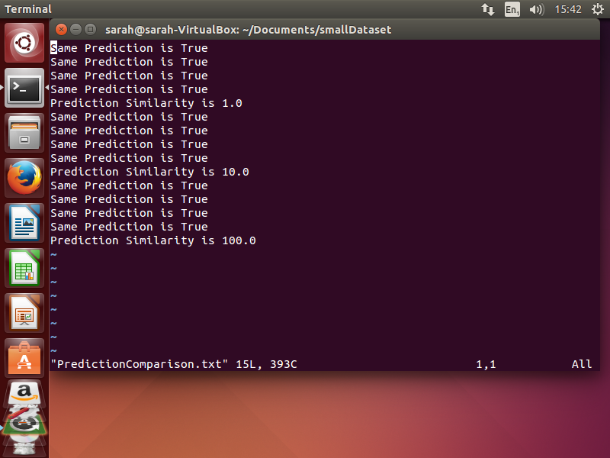

### 4.8 Product Testing

In order to test that each Naïve Bayes algorithm was working correctly, and both making similar predictions based on the same data it was important to conduct a number of different tests on their functionality.

Firstly, a test was required on the dataset manipulator. This was necessary to ensure that the data was always being randomly shuffled, and to ensure that both algorithms were being passed the same dataset each time. Testing this was done by running the script 3 times on each size dataset. Once this was done the output training and testing sets were then looked at, considering whether the data sets had an even spread of the data, whether the training and testing sets represented the 60/40 split of the data desired, and ensuring that each row of data was only included in either the training set or the testing set once. The results of these tests showed that each dataset was being correctly shuffled and represented a good spread of each dataset. This was confirmation that this script was correctly functioning, allowing the tester to move onto testing the main algorithms, knowing the inputs were correct. (Results for the testing on the small dataset attached in Chapter 9.6 as Appendix 6. Results for other datasets feature too much data to reasonably include in this report)

One way the standalone implementation was tested was by using black box testing, looking at the existing categorisation of the data and considering whether or not the Bayes classifier had made a reasonable prediction based on the data it had been given. This involved calculating the average number of correct predictions made with each dataset, and looking for any dramatically incorrect predictions as this could indicate issues within the underlying calculations made. During the testing stages, step by step print outs were given from the calculations done by this algorithm to make sure that they were all as would be expected at each step of the process. Overall, it was concluded that this test would be passed, and the standalone implementation considered functioning correctly, if the average accuracy of the predictions made on each dataset was above 75%. This allows the classifier some margin of error, which could be due to factors such as the spread of training data, or the fact that the data was not pre-processed, rather than the actual classifier not properly functioning. (Results for the accuracy of the predictions made can be found in chapter 5.2). As is shown by the test results, the accuracy of the standalone implementation was consistently higher than 75%, indicating no problems with the calculations being made. The averages did vary from 78.6% to 98.9% depending on which dataset was used, however this would be due to factors relating to the dataset, and not because of any more serious issues with the implementation.

The standalone Naïve Bayes classifier also underwent white box testing, this was used to check the calculations underlying the classifier were correct by passing in predetermined input data, and checking if it outputted the expected output. This was done using the medium sized dataset and supplying the algorithm with a fixed training set, containing 763 items. It was then passed the five remaining pieces of pre chosen and varied data as test data, to check whether or not it was able to correctly categorise each item. These pieces of testing data were chosen as they covered a spread of both categories, and because they contained some similar values which were then defined as different categories. This helped to pose more of a challenge to the algorithm. During these tests, print outs showing each step of the calculations were shown, allowing the tester to track exactly what the algorithm is doing during its prediction. Again, the accuracy required to consider this test a pass will be 75% or above, this allows the algorithm some error due to extraneous reasons, rather than incorrect design. The results of this test can be found in chapter 9.8, as appendix 8. As is shown in these results, the standalone Naïve Bayes algorithm correctly categorised 100% of the test data given to it. This result confirms that the underlying calculations of the algorithm are correct, as not a single mistake was made in this prediction.

Because of the results of the black, and white box testing conducted on the standalone Naïve Bayes algorithm, it can be said with confidence that this classifier is working as expected and correctly.

Testing the Spark implementation was slightly more difficult, as the calculations are all completed within the Spark framework, making it difficult to conduct the same white box testing as was undertaken for its standalone counterpart. Therefore, testing on this algorithm was done by checking the predicted values against the actual values and calculating an average for correct predictions. If this average was found to be over 75% accurate, and the predictions being made were seen as being rational and valid, then it could be concluded that this Naïve Bayes algorithm was functioning correctly. (Results for the accuracy of the predictions made can be found in chapter 5.2)

The results from this black box testing outputted averages ranging from 61.38% to 77.8%. These averages are considerably lower than the ones given by the standalone algorithm, and in the case of the medium dataset, are not high enough to pass this test. This presents a problem, as it becomes difficult to confidently state whether or not the Spark implementation is making accurate predictions, or whether it is simply making varied calculations that occasionally happen to be the correct ones. As two of the averages were high enough to pass this test, and only one average fails to meet the target, it can be assumed that the algorithm is making somewhat well considered and appropriately calculated predictions. Were white box testing possible it would have helped to support this algorithm’s validity, however as this is not a possibility the appropriateness of this implementation must be considered looking at other factors.

Overall it was concluded that the Spark implementation was still usable in this comparison, due to the fact it acceptably passed two out of three tests, therefore proving it can make appropriate predictions. The result of the failed test may have been down to the dataset used, or the lack of pre-processing the data, as this may have improved the accuracy of the results throughout.

An important requirement of these tests was that both Naïve Bayes Classifiers functioned as identically as possible, so testing this was vital in confirming a valid result. This similarity of predictions was tested by using the Prediction checker script, discussed in chapter 4.7. This script was run once after each test and outputted the percentage similarity of the predictions made by the Bayes Classifiers. These results were then recorded in a table, which can be found in chapter 9 as appendix 7, for further analysis once all of the tests were complete. If the outputs were found to be of a reasonable similarity, then it could be considered that these algorithms both functioned in a similar enough way to be comparable.

The results from these similarity tests did show that while sometimes more than half of the predictions were the same, the two algorithms generally tended to make different predictions when given the same datasets. This indicates different underlying calculations being made by the two implementations. This presents a problem when comparing the run times, as it becomes obvious that both algorithms are undertaking different methods and calculations. This however, while having an impact on the results, should not invalidate them. This is because it can be considered that both the Spark, and standalone algorithms function as Naïve Bayes Classifiers within their own right. This gives them a degree of similarity due to the fact that they are both based upon Bayes theorem, and function accordingly. The result of these tests will need to be brought forward and considered when making the comparison, and making any conclusions.

## 5. Comparing Standalone and Spark Naïve Bayes

Performance results will be gathered from the running of the Naïve Bayes algorithms, in regard to the speed and accuracy of each implementation on each size of dataset. When taking into consideration how to measure these results, the accuracy and relevance of the data must be considered.

The first result required is the real time speed taken for each algorithm to run. This could be measured in a number of different ways which vary in accuracy. The first, and least accurate way of measuring this would be to use a stopwatch. This method offers a very simple way of gathering this result. The tester would be required to start the stopwatch upon starting the algorithm, and then stopping the stopwatch when the algorithm is completed. This would give a real time for the running of the algorithm, however it is highly unlikely to gather an accurate result from this method, as the chances of the tester starting and stopping the stopwatch at the exact times are extremely low. Due to this, this method is unable to offer a time more accurate than to the nearest second, which in this case is not accurate enough.

Another, more accurate way of measuring the run time of both algorithms would be to use Pythons time.time() function. This function uses the time the algorithm was started, and the time the algorithm finished to calculate the run time. It could be implemented by setting ‘start’ to the time at the beginning of the script, and ‘end’ to the time at the end of the script, and then performing a calculation such as ‘end – start’ to give the time taken to run. It was eventually decided not to use this function. This was because while the implementation of it would be simple, it was deemed even more simple to use the time command in the Linux terminal, and this option would return an equally accurate timing.

Therefore, the chosen method of measuring the time taken was to use the Linux command line ‘time’ function. The time function is accurate down to the millisecond, and outputs the real time to three decimal places. This is plenty of accuracy for the results needed, and times the running of the entirety of each algorithm.

It was chosen to conduct each test of the algorithms on each dataset multiple times to counteract any possible miscellaneous results that might have occurred. It was decided to run each test 10 times, using different training and testing data for each test. This ensured that an even spread of the training data was given and therefore any extreme data in the training set would have less of an effect on the performance results of that test. The time in minutes and seconds was recorded for each test, and the accuracy of the algorithms, calculated by the number of correct predictions divided by the total number of predictions. An average time in seconds was then calculated for each sized dataset, and the average accuracy was also calculated.

### 5.1 Running the tests

The manner in which each test was conducted was kept the same throughout, to ensure that the results would be reliable. This involved running each of the scripts in the same order, and making sure to clear out any leftover directories or results files after each run. Before starting any test, it should be ensured that when the command ‘ls’ is used in the working directory, only the key scripts required to run the tests are found. This means the working directory should look like this example:

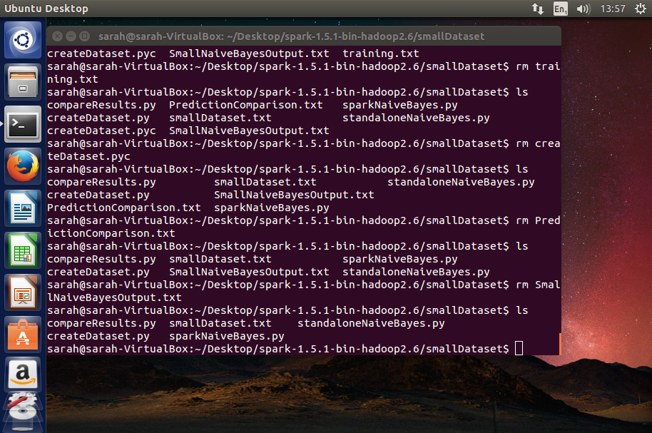

To conduct each test, the first script to be run was the standalone Naïve Bayes algorithm. This not only runs the Naïve Bayes algorithm being tested, but also the dataset manipulator script which creates the training and testing sets required for use in both algorithms. This was run using the ‘time’ command, to give the real run time of the script:

*time Python standaloneNaiveBayes.py*

Upon using this command, the standalone Naïve Bayes algorithm will be run, and the accuracy of the predictions made will be outputted to the console window, along with the real, user and system times for the run through. A text file will also be outputted, containing the prediction made by the algorithm, and the correct category from the test set. This is an example view of the output made to the console:

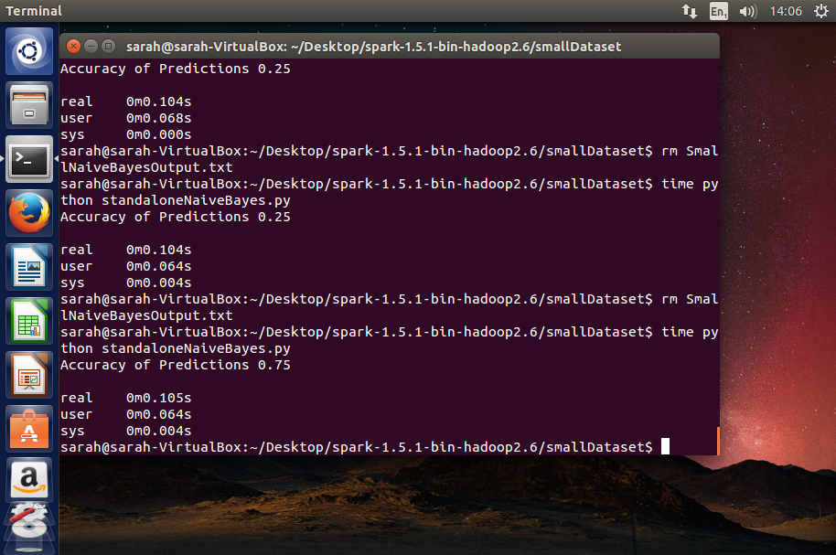

The output .txt file will be named using the size of dataset, followed by ‘Naïve BayesOutput.txt’, for example ‘SmallNaiveBayesOutput.txt’. An example of this file which was created after a run through of the test is shown below.

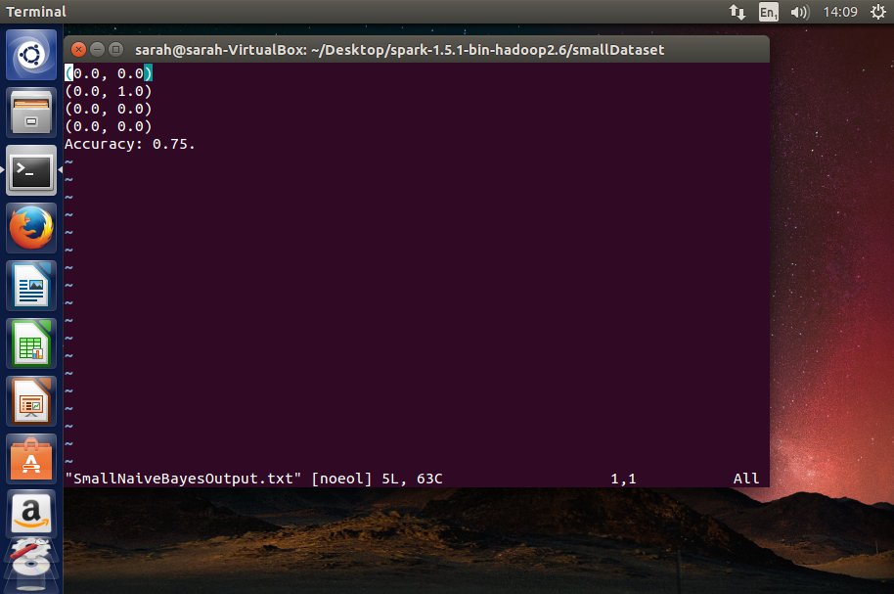

Having gathered all of the required information from this run, the test on the standalone implementation is complete, and the Spark implementation is next to be considered.

Before running the Spark implementation of Naïve Bayes it is important to check that the training and testing sets required for it are present. This can be done by using the command ‘ls’ in the console window and looking for the presence of ‘training.txt’ and ‘testing.txt’. These were created by the createDataset.py script and contain the input data for the Spark algorithm.

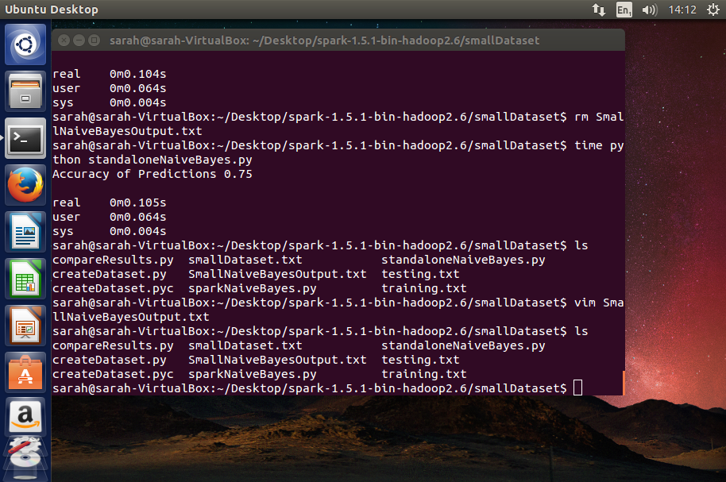

Once confirming that these are present, the Spark Naïve Bayes algorithm can be run. This is done using the command:

*time .././bin/Spark-submit --master local[4] SparkNaiveBayes.py*

Upon completion of this run through the real, user and system times are again outputted, along with the creation of the directory Prediction, which contains the results file, and a file which confirms the run was a success.

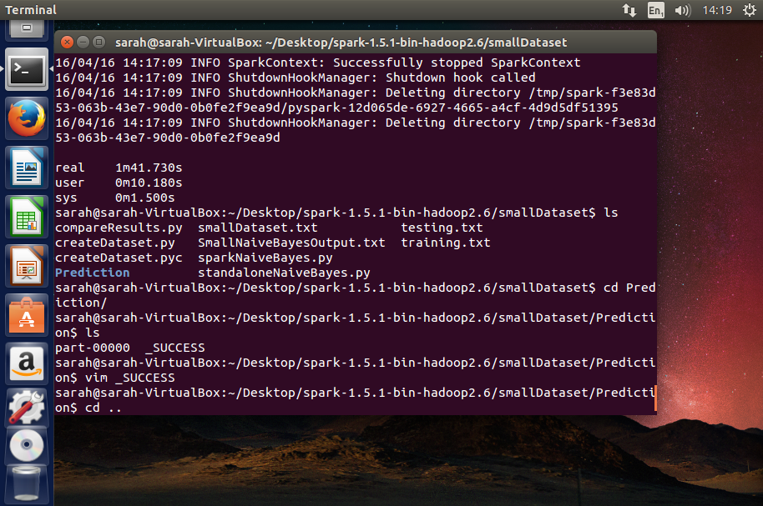

Now that both Bayes Classifiers have been run, and their results are saved to text files, the prediction and accuracy checker can be used to check the similarities of the results. This is done by running the ‘compareResults.py’ script, using the command:

*Python compareResults.py*

This script will then print out four lists, two representing the predictions made by each classifier, and two which show to correct categories of the data. It also prints out whether or not the predictions match, by printing out True, or if they do not match by printing out False.

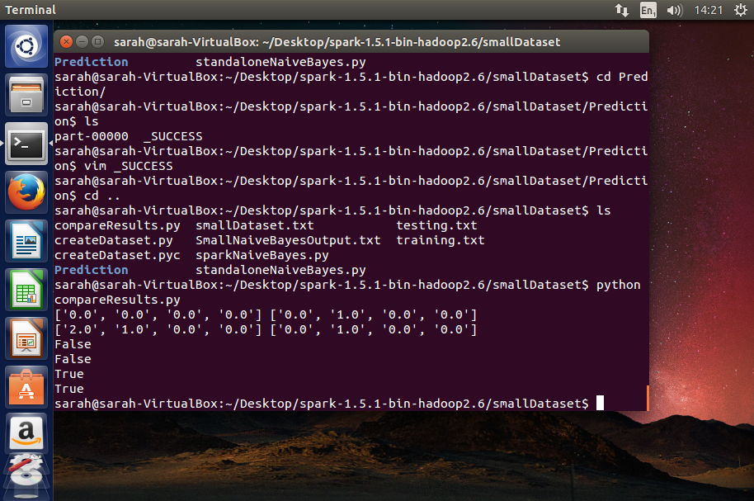

This information is all printed out into a text file called ‘PredictionComparison.txt’, along with the percentage of same predictions.

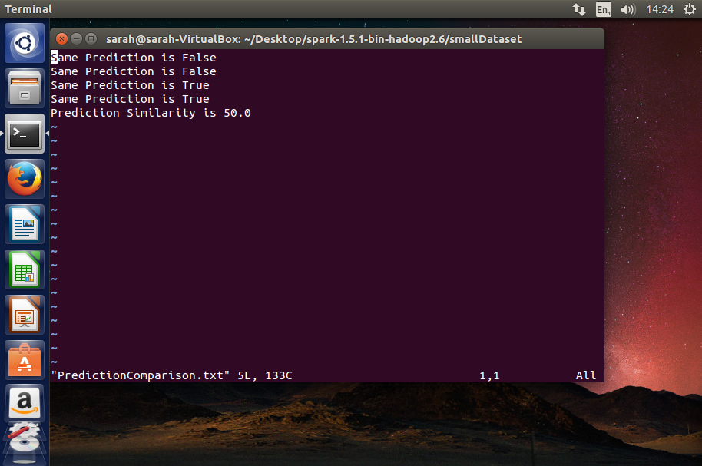

Once all required data is gathered from these runs, the directory must be cleared out, removing all results files, before beginning the test again on a different dataset.

### 5.2 Performance Test Results

#### 5.2.1 Standalone Naïve Bayes on a Small Dataset

8 pieces of Training Data, 4 of Test Data

|  |  |  |
| --- | --- | --- |
| **Test Number** | **Real time** | **Accuracy** |
| **1** | 0.105s | 75% |
| **2** | 0.104s | 50% |
| **3** | 0.105s | 100% |
| **4** | 0.109s | 75% |
| **5** | 0.105s | 75% |
| **6** | 0.130.s | 100% |
| **7** | 0.109s | 75% |
| **8** | 0.121s | 100% |
| **9** | 0.117s | 100% |
| **10** | 0.116s | 75% |

Average Time taken = 0.102s

Average Accuracy = 82.5%

5.2.2 Apache Spark Naïve Bayes on a Small Dataset

8 pieces of Training Data, 4 of Test Data

|  |  |  |
| --- | --- | --- |
| **Test Number** | **Real time** | **Accuracy** |
| **1** | 1m23.581s | 75% |
| **2** | 1m27.733s | 50% |
| **3** | 1m36.799s | 100% |
| **4** | 1m24.296s | 50% |
| **5** | 1m33.127s | 50% |
| **6** | 1m15.291s | 100% |
| **7** | 1m10.565s | 75% |
| **8** | 1m7.925s | 100% |
| **9** | 1m4.960s | 100% |
| **10** | 1m8.051s | 75% |

Average Time taken = 1m19.233s

Average Accuracy = 77.5%

#### 5.2.3 Standalone Naïve Bayes on a Medium Dataset

460 pieces of Training Data, 308 of Test Data

|  |  |  |
| --- | --- | --- |
| **Test Number** | **Real time** | **Accuracy** |
| **1** | 0m16.056s | 98.6% |
| **2** | 0m15.207s | 99.1% |
| **3** | 0m16.115s | 99.3% |
| **4** | 0m15.441s | 98.1% |
| **5** | 0m16.601s | 99.6% |
| **6** | 0m17.884s | 97.7% |
| **7** | 0m17.423s | 99.4% |
| **8** | 0m17.760s | 98.2% |
| **9** | 0m16.331s | 99.8% |
| **10** | 0m17.309s | 99.2% |

Average Time taken = 16.6126s

Average Accuracy = 98.9%

5.2.4 Apache Spark Naïve Bayes on a Medium Dataset

460 pieces of Training Data, 308 of Test Data

|  |  |  |
| --- | --- | --- |
| **Test Number** | **Real time** | **Accuracy** |
| **1** | 1m34.824s | 60.7% |
| **2** | 1m9.916s | 59.2% |
| **3** | 1m5.726s | 59.4% |
| **4** | 1m8.552s | 67.0% |
| **5** | 1m16.694s | 58.4% |
| **6** | 1m19.459s | 63.3% |
| **7** | 1m14.378s | 58.4% |
| **8** | 1m14.334s | 67.3% |
| **9** | 1m20.171s | 63.6% |
| **10** | 1m19.550s | 59.7% |

Average Time taken = 1m16.3604s

Average Accuracy = 61.38%

#### 5.2.5 Standalone Naïve Bayes on a Large Dataset

1200 pieces of Training Data, 800 of Test Data

|  |  |  |
| --- | --- | --- |
| **Test Number** | **Real time** | **Accuracy** |
| **1** | 20m9.653s | 81.1% |
| **2** | 20m13.800s | 76.8% |
| **3** | 20m21.842s | 79.4% |
| **4** | 20m17.572s | 82.1% |
| **5** | 20m14.339s | 77.2% |
| **6** | 20m12.739s | 79.1% |
| **7** | 20m16.834s | 80.6% |
| **8** | 20m22.373s | 79.5% |
| **9** | 20m18.937s | 81.3% |
| **10** | 20m10.479s | 78.9% |

Average Time taken = 20m15.8568s

Average Accuracy = 79.6%

5.2.6 Apache Spark Naïve Bayes on a Large Dataset

1200 pieces of Training Data, 800 of Test Data

|  |  |  |
| --- | --- | --- |
| **Test Number** | **Real time** | **Accuracy** |
| **1** | 1m16.083s | 74.6% |
| **2** | 1m26.798s | 73.9% |
| **3** | 1m18.493s | 75.4% |
| **4** | 1m16.947s | 74.6% |
| **5** | 1m20.480s | 73.8% |
| **6** | 1m14.726s | 76.2% |
| **7** | 1m12.390s | 75.1% |
| **8** | 1m16.993s | 74.7% |
| **9** | 1m14.638s | 76.8% |
| **10** | 1m15.002s | 75.3% |

Average Time taken = 1m17.255s

Average Accuracy = 75.041%

### 5.3 Analysis of Test Results

The results gathered by these test runs were then converted into line graphs to provide a better visual representation. The first graph created was of the average run time for each dataset for both the standalone and Spark scenarios, this is shown below:

As can be seen in the graph above, the Spark implementation maintained fairly consistent run times, varying throughout the tests by approximately 30 seconds, despite a significant difference in the sizes of the datasets. This suggests that overheads, rather than size of data, have a much more significant impact on the run time of Spark implementations. The opposite of this is true for the standalone implementation as it can be seen that the run time increases each time more data is passed to the algorithm. As is very obvious from the graph, the time taken for the largest dataset to be analysed varies greatly between these two implementations. The standalone Naïve Bayes takes a significantly longer amount of time to both train, and predict using this dataset. A reason for this is down to the sheer amount of data required to be passed into the Naïve Bayes algorithm in order to train it. This takes much longer done sequentially and has had a large impact in the result for this dataset. This finding helps support the initial theory of this project, that the standalone implementation would not be as able to handle the large dataset as the Spark implementation would.

Another graph was then created, showing the average accuracy of the predictions made by both implementations of the Bayes Classifier on each size of dataset. This graph shows that overall the standalone implementation was more accurate than the Spark implementation. This is an unexpected finding, as it was assumed at the start of the project that both implementations would have similar levels of accuracy. A reason for this, may be due to the fact that no pre-processing or smoothing of the data was undertaken for this Spark implementation. An issue leading to it being less accurate may be the lack of inclusion of an m-estimate, which works in a Naïve Bayes algorithm to eliminate the chances of a zero probability. A result equalling in a zero probability will have a large effect on the predictions made by a classifier, as it leads to the classifier performing multiplications by the value 0. This will always output a result of 0, meaning that there will be no chance this category will be chosen as the predicted category.

This graph also shows how differently the two approaches were able to handle the data. The standalone implementation performed the best on the medium sized dataset, classifying it almost 100% correctly. The Spark implementation however struggled with this dataset, as it only successfully predicted around 60% of the test data. Many reasons can be considered for this variation in results, as this dataset was the most different from the other two. The medium sized dataset was unlike the other two data sets in that it did not contain integers, it contained floats. While it was not predicted that this would have had an impact on the results, this may have been the case, and this may have hindered the Spark classifier while making its predictions. Another, highly important factor to consider was that this dataset could only be classified into two categories, 0 and 1. This may have contributed to the high accuracy of the standalone implementation, as there were many less categories to consider the values for. The Spark classifier however had the same data to make its predictions with, so it is an unexpected result that it made such low predictions given this dataset.

The results for the large dataset show a dip in accuracy for the standalone classifier, and an increase in accuracy for the Spark classifier. It may be the case that this is around the point where the Spark implementation begins to become invaluable, as it is much better prepared for dealing with this amount of data. A fact that was brought forward from the initial review of the literature was that generally, Naïve Bayes algorithms are much more accurate when used on smaller datasets, however don’t scale well (Ron Kohavi, no date). This could be shown on the graph by the dip in accuracy, however this could only be confirmed were both algorithms tested again on an even larger set of data. It would be predicted that the accuracy of the standalone algorithm would then drop further, and the Spark accuracy would begin to increase.

### 5.4 Comparison of the two solutions

When starting this project, four categories were identified to be further investigated to aid in making a comparison between these two solutions. These were the overall performance of each piece of software, the ease of use of each, their individual methods of data processing and what this means in regard to what data is best analysed using this solution, and how failure tolerant each of these are.

The first category that will be considered is the overall performance of each solution. In this case this will cover the speed, and accuracy of both of solutions. Overall this result was slightly different than what was initially expected in the case of the Spark implementation. It was initially expected for the Spark classifier to be more accurate than it actually was, this could be due to a number of reasons, the main one being its lack of use of an m-estimate to remove the chances of zero probability bias. It was predicted that the accuracy of the Spark implementation would increase as the datasets got larger, which was true in the case of the large data set, but to further prove this the classifier would need to be re-tested using a larger dataset and the average calculated.

In regard to the standalone Bayes classifier, this performed roughly as was expected. This classifier had a high average accuracy on the smaller two datasets, however struggled to maintain this accuracy as the dataset became large. This could also be further proved by testing upon an even larger dataset, as this would confirm whether the accuracy of the algorithm did continue to decrease on even bigger datasets.

Considering the run time of each solution was also important to get a view on their overall performances. As made clear by the graphs in chapter 5.3, the Spark implementation had a very consistent average run time despite changes in the size of datasets. This shows how little the data size impacts on the run time, and therefore implies that factors such as bottle necking will have a much larger impact on this solution. This helps to confirm initial ideas that the Spark solution was a much better option for very large datasets, as it cut down the run time of the classification by a large amount.

When looking at the average run time of the standalone solution it becomes very clear the impact the size of the dataset has on this algorithm. The run time can be seen increasing significantly between the medium and large size datasets. On average it took the standalone Bayes classifier just over 20 minutes to run through and classify the large dataset. This shows how impractical using this kind of solution is on any extreme sized datasets, as if this classification was needed to be done in real time, or with any urgency, this solution would not be able to provide that.

Next to consider was the ease of use of the two solutions. This was considered during the implementation of both of these classifiers. The Spark solution was implemented using the MLlib libraries provided. This made writing this algorithm incredibly simple, as there was no need to write out the calculations, or look too deeply into the actual workings of the Naïve Bayes algorithm. In order to write a Spark Naïve Bayes, the user need not have any knowledge of the actual Naïve Bayes calculations, and needn’t understand Bayes theorem. Every high level calculation is done within the Spark framework and the user need only correctly use the functions provided and an acceptable Naïve Bayes classifier can be created.

On the other hand, the standalone implementation was written without similar libraries, therefore a good understanding of Naïve Bayes was required in order to ensure the correct calculations were being undertaken. This took a considerable amount more time, and many, many more lines of code were required to write the same algorithm. This is however something that could be improved, as Python modules such as SciPy do offer libraries containing Naïve Bayes functionality. Overall it can definitely be concluded that Spark offers a much more user friendly approach to implementing Naïve Bayes, and therefore offers the better solution for someone who does not wish to go too into detail in learning Bayes theorem.

A further feature to consider was the difference in performance between the sequential and parallel methods of these solutions. In this set of tests the way this is measured is by the run time of each solution. When comparing the run time of both the standalone and Spark solutions, it becomes obvious the effects that the use of parallel processing has on these algorithms. As is seen in the standalone implementation, the run time greatly increases when more data is passed into the classifier. This is due to the fact that each item in the dataset must be processed fully, before the classifier can move onto the next item. This leads to the increase in run time as the solution works its way through the data, one item at a time.

The Spark solution is implemented in parallel, and uses a lazy evaluation method. This means it does not have to run through each item in the dataset in order as the standalone solution does, and it can wait until it has been given every command and then use all the information given to make its prediction. This helps save time when processing the large amounts of data, keeping the run time to a consistently low level.

Failure tolerance is the last category to be investigated in this comparison. In the end, this project did not have time to fully investigate and test the failure tolerance of both of these solutions, however during research and some investigation some insight into this category was gained. The reason that it became difficult to test the failure tolerance of both systems was because the standalone classifier doesn’t have any method of failure tolerance. In that solution, if a problem occurs during data analysis then the progress was lost and the analysis was required to be re-started, from the first instance of data. In the Apache Spark solution, no failure tolerance was implemented, in order to keep the two solutions similar, however it does offer features to make it fault tolerant. In a Spark MLlib solution, it is possible to save the Naïve Bayes Model that is created using the training data. This can be saved to, and loaded from at any point, and therefore allows the analysis to be retrieved if anything should go wrong. This is something that could be considered in further research into this topic.

Overall, different strengths and weaknesses can be found in each of these solutions. Based on the test results and conclusions of the comparison, it can be seen which types of dataset, and which scenarios would benefit most from each solution.

Based on both this study, and conclusions from the research of literature, it can be stated that the standalone Naïve Bayes Classifier is best used in analysing smaller datasets. Used on these datasets it offers a high level of accuracy, and reasonable run times. It would be unwise to attempt to analyse any larger sized datasets using this solution, as the run times would become impractical and the accuracy would be greatly impacted.

The best solution to analyse a large dataset would be to use a Naïve Bayes Classifier implemented using Apache Spark’s MLlib libraries. This offers better accuracy, and a much more reliable run time, as long as the system has adequate hardware resources so as to avoid bottle necking. The Spark implementation is also a good solution for someone less experienced in data mining or machine learning algorithms as it is very easy to use. Analysing small datasets using this solution would not be advised, as the run time will be much longer than necessary, due to the Spark overheads.

## 6. Evaluation of the Work Done and the Project Process

### 6.1 Evaluation of work done

In considering whether or not the work done was appropriate and successful, many aspects of the final tests must be considered. One of the main considerations for deeming this solution a valid one, is being able to state that both the Spark, and Standalone implementations of the Naïve Bayes Classifiers are functioning in the exact same manner.

In order to determine if this is the case or not, one test that should be considered is the prediction and accuracy checker. This test was used to check whether or not each prediction made by both algorithms, using the same input data, was the same. If both implementations functioned in an identical manner then the result of this should be that when given the same training and testing data, each prediction made should be identical. The results of this test can be found in chapter 9.7, as Appendix 7. As is shown in these results, approximately 60% of the predictions made by each algorithm were identical. This result is lower than would have initially been hoped, as it indicates differences in the way that each of the Naïve Bayes algorithms are making calculations. This presents issues in not just the overall comparison, but poses the problem that either one of the Naïve Bayes algorithms may not be making correct calculations, and that has led to the difference in predictions.

To further investigate this issue, it must be determined that each Naïve Bayes algorithm is functioning correctly. If this can be confidently stated then the comparison between the solutions can still be considered valid, however minor impacts will have been had on the results, due to slightly different methods.

The condition of a successful working Bayes Classifier, stated during the black box testing of these algorithms, was that each algorithm should have an average accuracy of 75% or above of correct predictions for each of the datasets it was run upon.

When considering the black box test results for the standalone Naïve Bayes Classifier, as can be found in chapter 5.2, the average percentages of correct predictions are consistently above 75%, ranging from 79.6%, to 98.9% accuracy. This suggests that this implementation is making both sensible, and reliable predictions when given any amount of data. Due to the consistently high accuracy of these predictions it can be reasonably stated that the implementation of this standalone classifier is both successful, and appropriate for testing upon. Coupling this with the results from the white box tests, which confirm that the algorithm is making the predictions it is expected to, it can be stated that this algorithm functions correctly.

When then taking into account the Spark test results, which passed when run on two of the datasets, but not the third, it becomes harder to state the appropriateness of these implementations. It was found that the Spark classifier was less accurate overall, and when looking at the results of the similarity of predictions tests, it can be seen that each algorithm is using the datasets differently to make similar, but not the same predictions. It was concluded that while the Spark implementation failed one test, it was still obviously making sensible predictions, as is shown by the fact that it passed two of the tests. This allows us to state that this algorithm, while not without flaws, is still appropriate and can be used to make reasonable comparisons, should the discrepancies relating to different calculations be taken into account.

Overall, it can be seen that there are flaws in this implementation, concerning the similarities of the calculations being performed. This does not invalidate the project as a whole, but does lead to the addition of more extraneous variables needing to be considered in the final conclusions made.

In order to help eliminate this weakness, a different method of design and implementation could have been undertaken. It may have been more appropriate to have initially implemented the Spark Naïve Bayes algorithm. Once this was implemented, the source code for this implementation, which can be found within the Spark repository, could have been more widely consulted. This may have been used to aid in the design of the standalone implementation, which would have followed in the methods used by Spark. This would have led to a more similar implementation, rather than simply designing a functioning Naïve Bayes Classifier as was done and assuming that the methods used would be similar.

One thing that can be considered a strength of this project was the conditions of the tests being kept to the same standard. This is seen in the identical running order of the tests, the consideration of the environment on which the tests were undertaken, and the range of varied and unbiased data being passed to the algorithms. Due to these measures, many factors that could have impacted on the results, such as variations in the virtual machine, were eliminated. This helps towards making final conclusions as it helps to eliminate various factors that would otherwise need to be considered in the results.

### 6.2 Evaluation of project process

Initially this project aimed to make a comparison between Apache Spark and Hadoop’s Map Reduce, however upon commencement of the project it was realised how complex doing this would be. Once started it became obvious that in order to complete a full comparison between Spark and Map Reduce, a standalone version of the Naïve Bayes algorithm would be necessary to act as something to compare to. The time to write and test this standalone version was not considered in the initial plans and therefore changed the scope of the project. The decision to drop the Map Reduce implementation was made after research conducted during the literature review, which suggested Spark as a more up and coming data mining solution, over the older Map Reduce. No longer looking into Map Reduce and focusing the project on the newer Apache Spark allowed for a more useful and in depth evaluation of this solution and its benefits in the data mining field.

As the project was undertaken using an Agile method of development this allowed some flexibility in altering the aims of this project slightly to encompass a comparison between parallel and sequential methods of big data analysis. As changes needing to be made to the initial plan were discovered, the project plan was adapted to include these changes. This required a constant consciousness of timing, and it was necessary to keep any plans made as flexible as possible. This approach to development allowed the overall project to flow more naturally, and gradually evolve into the most relevant and effective solution possible. Had this project have been undertaken in a more rigid design method it would have been difficult to have taken the conclusions found in the review of literature forward into the implementation.

When compared to the Project Plan included in the Terms of Reference (Appendix 8.1), the overall timings of the project kept within the initial plans for each deliverable. The change in implementing a standalone Naïve Bayes algorithm, rather than a Map Reduce version, fitted in easily to the plan, as during the time it was suggested to be designing and implementing the Map Reduce equivalent, the standalone version was instead developed. Not considered in the Project Plan was the implementation of the dataset manipulator and the prediction checker scripts. These were both developed upon completion of both implementations of Naïve Bayes and were done during the time initially given to testing both algorithms. This pushed back the time given for testing by approximately a week, however as an extra two weeks were initially allocated for final touches, this did not have an effect on the finish date of the project. One thing that can be taken away from this project is the importance of allocating extra time for any changes that may crop up during development. Because this extra time was given the project was able to adapt to the ever evolving requirements, whilst still remaining within schedule.

At the start of the project a major issue was trying to find appropriate data sets to use that not only contained solely numerical data, but also were not missing any values from the dataset, were available open source, and held enough instances of the data to be considered a ‘large dataset’. Originally, it was intended to find one large dataset and split that into smaller sets to use as a small and medium sized dataset. This was changed as Apache Spark offered a small dataset within its MLlib directories called ‘sample_naive_bayes_data.txt’. This dataset was used for the initial testing of both implementations of Naïve Bayes, and eventually it was decided it would also work well as the smallest dataset. The medium sized dataset ‘pima-indians-diabetes.data.txt’ was found relatively easily as it is often used in basic Naïve Bayes classification as a test.

An appropriate large dataset was the most difficult to find. This was due to the fact that many large datasets are either missing values, or were simply too large for the scope of this project. Of the datasets acquired many were around 10,000 samples of data and running these on the standalone Spark took up to three hours and more. This was too long as often the Virtual Machines running them would go to sleep and this could have had an effect on the run time of the algorithms. It was concluded that using a sample from a large dataset containing many attributes was the best solution to this, as the data could still be considered large, however it was not so large it was unfeasible.

During the testing of both algorithms it became a problem that each algorithm was creating different testing and training sets from the data. This was discovered when a comparison of the results was needed to be made, however it could not be seen whether or not the algorithms would have made the same predictions as they had both been given different training data and were being tested on different samples. The solution to this was to create the Dataset Manipulator to ensure all data passed to algorithms was the same. This was unplanned in the initial project process and required an extra Python script to be written to ensure similarity.

Overall, this project succeeded in meeting most of the learning objectives set out in the terms of reference, with slight changes regarding the removal of a MapReduce solution and inclusion of the standalone solution. Objective 2, to create design documentation for the solution, was not met however. This was due to the changes in scope, as this method of design would have been most appropriate when used to plan a MapReduce solution due to its complexity. In the final project it was only necessary to fully design the tests as a whole, this was to ensure that the tests would produce thorough and valid results. Design was not required for each algorithm as it merely needed to follow the structure of a Naïve Bayes algorithm and therefore having this outlined was enough.

Over the duration of the project I have gained and developed a number of my personal skills:

Naïve Bayes – I have gained a far greater understanding of the Naïve Bayes algorithm, and have understood more of the effects that pre-processing can have on the effectiveness of this solution.

Apache Spark – I have gained knowledge of RDD’s, and the transformations and actions required to use these effectively. I have also learnt more about the effects of benchmarking, and its importance when running time conscious systems.

Numpy – Having used Python’s Numpy in many of the scripts written I have gained a better understanding of these libraries, and when it is more appropriate to use it than it would be to use a Python list.

I have also constantly been developing my knowledge of Python, and my ability to use the Linux command terminal.

## 7. Conclusions and Suggestions for further research

### 7.1 Conclusions

This project set out to investigate the differences in performance between the sequentially implemented standalone Naïve Bayes Classifier, and the parallel Apache Spark Bayes Classifier. It aimed to look in depth into the overall performance, ease of use, methods of data processing and how failure tolerant each of these solutions are. This was done to help identify which solution was the best used in different data mining situations.

The first major conclusion that can be drawn from this project was the suitability of an Apache Spark implemented classifier for analysing big datasets. This conclusion was one that was predicted to be found, based on research into relevant literature, and the results and findings from the tests backed up these initial theories.

It was found that the Spark solution had very consistent run times, and was not impacted by the increase in size of datasets that were being passed to the classifier. When compared to the run times of the standalone solution, this showed how large an impact using a solution such as Spark can have on a big data analysis problem. A critical factor in big data analysis is handling all of the data within a time frame in which the information gathered will still be relevant. Spark allows for this much more than a standalone solution would, offering the ability to run the processes in parallel, on multiple nodes, and distributed over a cluster.

The Spark solution was found to be less accurate than its standalone equivalent on each set of data. This was not something predicted to be seen at the start of the project, and therefore was not as prepared for as it could have been. The solution implemented for these tests featured no m-estimate, and used only the default value for smoothing the data. It can be considered that this does not fairly represent the accuracy of Spark’s MLllib Naïve Bayes solution, as in reality these measures would have been undertaken in order to gain the accuracy required. This is something that would need to be further investigated in continuing pieces of research.

One thing that can be stated for the accuracy of the Spark Naïve Bayes algorithm was noted during the comparison between it, and the accuracy of the standalone solution. This was the increase in accuracy noticed when analysing the large dataset, compared with the decrease in accuracy of the standalone solution’s predictions. One thing identified by the investigation into relevant literature was the fact that a standalone Naïve Bayes algorithm will become increasingly less accurate as more data is given to it, making it especially impractical for analysing larger datasets. This was confirmed by this finding, however in order to be able to confidently conclude that the Spark solution will continue to increase in accuracy when given an even larger dataset, this would need to be further tested using an even larger dataset.

When considering which solution to use in different data analysis scenarios, this project has offered some insight into making this decision. It can be concluded from the research undertaken during the project that a Spark solution is the most effective when used on large, to extreme sized datasets, and that if used on a smaller dataset it will not perform as well as a traditional standalone equivalent. The ability to be fault tolerant also makes Spark a better solution for larger datasets, as it is more detrimental to scenarios involving large amounts of data if a fault does occur and all previous analysis lost. A Spark solution offers easier implementation, and is therefore helpful in cases where a limited knowledge of the theories behind Naïve Bayes is held.

In cases of smaller, to medium sized datasets, the best solution remains a sequentially implemented standalone solution. On these types of datasets, a standalone Naïve Bayes algorithm can function within a reasonable time frame, and make predictions to a high accuracy. A Spark implementation used on these smaller datasets would not add any benefits to speed, or accuracy, and therefore is not recommended.

7.2 Suggestions for further research

One recommendation for further research into this area would be to conduct the tests again, using the new, more up to date version of Apache Spark. Between the initial download of Spark and the write up of this report Apache Spark has been updated to version 1.6.1. This update took place on March 9, 2016 and contains updates to the API, performance, UI, and adds new algorithms and models to MLlib. This update could have an effect on the speed of Spark, and the features available when using the Python MLlib libraries.

One major consideration for further work, based on this project would be continued work into getting both Naïve Bayes exactly the same to further validate the results. While the results and conclusions from this project are reasonably valid, to obtain an exact comparison between these two systems would require two identically implemented Bayes Classifiers. If possible, the Python implementation would need to identically follow the method used by the Spark implementation, and not simply be reasonably similar.

Further research could also be done into the algorithm used in data mining, for example using other algorithms supported by Spark’s MLlib libraries, such as the linear support vector machine (SVM), rather than a Naïve Bayes Classifier. This would allow further insight into the accuracy of data mining algorithms and whether Spark’s utilities for different algorithms are well supported.

Another area of future research could be to implement the Naïve Bayes Classifier onto Hadoop’s Map Reduce and test that in a similar manner. This would offer insight into another widely used data mining solution and could help to identify the strengths and weaknesses of each solution. The conclusion of this could improve the usage of each of these solutions by suggesting which data mining solution each is most suited for, and therefore allowing them to be used to their full potential.

Furthermore, use of other programming languages supported by Apache Spark could also be tested upon, for example using Scala. Within Apache Spark each language has different features, with Scala being the most largely supported within the MLlib libraries, so it may alter the efficiency of the tests and add new subjects which could be investigated.

Finally, a further study could be undertaken into methods of improving the Apache Spark implementation of Naïve Bayes, using pre-processing of the data to see if it impacts the accuracy of the predictions made. It could also further investigate the speed of data mining using Spark, looking more in depth into the effects of bottlenecking and considering which hardware resource has the greatest impact on this.

## 8. References

Apache SparkTM - lightning-fast cluster computing (no date) Available at: http://Spark.apache.org/ .

Becker, S. (2001) ‘Data warehousing and web engineering’, .

Borthakur, D. (2007) ‘The Hadoop Distributed File System: Architecture and Design’, The Apache Software Foundation, .

D.Cook, J. (2009) John D. Cook. Available at: http://www.johndcook.com/blog/2009/07/06/brewer-cap-theorem-base/ .

Dean, J. and Ghemawat, S. (2010) ‘MapReduce: A flexible data processing tool’, .

Dean, J. and Ghemawat, S. (no date) ‘MapReduce: Simplified data processing on large clusters’, .

Fan, W. and Bifet, A. (2012) ‘Mining big data: Current status, and forecast to the future’,

Fayyad, U., Piatetsky-Shapiro, G. and Smyth, P. (1996) ‘From Data Mining to Knowledge Discovery in Databases’, AI MAGAZINE, .

Gopalani, S. and Arora, R. (2015) ‘Comparing Apache Spark and map reduce with performance analysis using k-means’, International Journal of Computer Applications, 113(1), pp. 975–8887.

Hall, L.O., Chawla, N. and Bowyer, K.W. (no date) ‘Decision tree learning on very large data sets’, .

Han, J. (1996) ‘Data mining techniques’, ACM SIGMOD Record, 25(2), p. 545. doi: 10.1145/235968.280351

Henley and Hand (1996) ‘Nearest neighbor analysis in credit scoring’, 45.

Jain, A.K. (2010) ‘Data clustering: 50 years beyond k-means q’, Pattern Recognition Letters, 31, pp. 651–666. doi: 10.1016/j.patrec.2009.09.011.

Karau, H., Konwinski, A., Wendell, P. and Zaharia, M. (2015) Learning Spark: Lightning-fast big data analysis. ‘O’Reilly Media, Inc.’

Keerthika, G. and Saravana Priya, D. (2015) ‘Feature Subset Evaluation and Classification using Naive Bayes Classifier’, Journal of Network Communications and Emerging Technologies (JNCET), 1(1).

Kohavi, R. (no date) ‘Scaling Up the Accuracy of Naive-Bayes Classiers: a Decision-Tree Hybrid’, Data Mining and Visualization, .

Lewis, D.D. (1998) Naive (Bayes) at forty: The independence assumption in information retrieval. Springer Science + Business Media.

Lohr, S. (2014) Big data’s impact in the world. Available at: http://www.nytimes.com/2012/02/12/sunday-review/big-datas-impact-in-the-world.html?_r=0 .

Maycotte, H.H.O., Umbel and Contributors, I. (2016) The evolution of big data, and where we’re headed. Available at: http://www.wired.com/insights/2014/03/evolution-big-data-headed/ .

McCallum, A. and Nigam, K. (no date) ‘A Comparison of Event Models for Naive Bayes Text Classification’, .

McKinsey and Manyika, J. (2011) Big data: The next frontier for innovation, competition, and productivity. Available at: http://www.mckinsey.com/business-functions/business-technology/our-insights/big-data-the-next-frontier-for-innovation .

Meng, X., Talwalkar, A., Sparks, E., Smith, V., Pan, X., Venkataraman, S., Zaharia, M., Griffith, R., Duchi, J., Gonzalez, J., Franklin, M., Jordan, M.I. and Kraska, T. (no date) ‘MLlib: Scalable machine learning on Spark’, .

Metsis, V., Androutsopoulos, I. and Paliouras, G. (no date) ‘Spam filtering with Naive Bayes – which Naive Bayes? *’, .

Minnier, J., Yuan, M., Liu, J.S. and Cai, T. (2015) ‘Risk classification with an Adaptive Naive Bayes kernel machine model’, Journal of the American Statistical Association, . doi: 10.1080/01621459.2014.908778doi.org/10.1080/01621459.2014.908778.

Murphy, K.P. (2006) ‘Naive Bayes classifiers’, .

Palace, B. (1996) Data mining: What is data mining?. Available at: http://www.anderson.ucla.edu/faculty/jason.frand/teacher/technologies/palace/datamining.htm .

Piatetsky-Shapiro, G. (1996) ‘Knowledge discovery in real databases: A report on the IJCAI-89 workshop’, .

Puga, J.L., Krzywinski, M. and Altman, N. (2015) ‘Points of significance: Bayes’ theorem’, Nature Methods, 12(4), pp. 277–278. doi: 10.1038/nmeth.3335.

Quinlan, R.J. (1999) C4.5: Programs for machine learning: Programs for machine learning: Book and software package. United States: Morgan Kaufmann Publishers In.

Rish, I. (2001) ‘An empirical study of the Naive Bayes Classifier’, .

Sebe, N., Lew, M.S. and Huang, T.S. (2004) Computer vision in human-computer interaction: ECCV 2004 workshop on HCI .. Springer Science & Business Media.

Trnka, A. (2014) ‘Big Data Analysis’, European Journal of Science and Theology, 10, pp. 143–148.

Venner, J. (2009) ‘Pro Hadoop’, .

Welcome to ApacheTM Hadoop®! (2014) Available at: http://hadoop.apache.org/ .

White, T. and Cutting, D. (2009) Hadoop: The definitive guide. United States: O’Reilly Media, Inc, USA.

Witten, I. (2005) Data mining: Practical machine learning tools and techniques, 2nd edition. Edited by Eibe Frank. Second edn. India: Harcourt India Private.

Wu, X., Kumar, V., Ross, ·.J., Quinlan, Ghosh, J., Qiang, ·., Hiroshi, Y.·., Mclachlan, G.J., Ng, A., Liu, B., Yu, P.S., Zhou, Z.-H., Steinbach, M., Hand, D.J., Steinberg, D., Wu, X., Kumar, V., Quinlan, R.J., Ghosh, J., Yang, Q. and Motoda, H. (2007) ‘Top 10 algorithms in data mining’, Knowl Inf Syst, 14, pp. 1–37. doi: 10.1007/s10115-007-0114-2.

Zaharia, M., Chowdhury, M., Das, T., Dave, A., Justin, Mccauley, M., Franklin, M.J., Shenker, S. and Stoica, I. (no date) ‘Resilient distributed Datasets: A fault-tolerant abstraction for in-memory cluster computing’, .

## 9. Appendices

### 9.1 Appendix 1 – Terms of Reference

**Background to Project**

The title of this final year project is ‘A comparison between Apache Spark and Map Reduce on Hadoop’. During the course of the project I intend to make an in depth comparison between the functionalities of both Apache Spark and MapReduce running on Hadoop. I intend to do this by implementing a Machine Learning algorithm with each of these frameworks and comparing their performance, ease of use, their methods of data processing, how failure tolerant each of these systems are, and any other areas that I feel will help me form a relevant and fair comparison between the two.

The problem domain I will be working in is the Internet of Things domain. The Internet of Things refers to the connection of physical, everyday objects to the Internet, allowing data to be gathered from systems embedded into these objects, such as sensors. In recent years the expansion of the Internet has grown exponentially and new ways to use the Internet to benefit society have also evolved. One example of this in which I am particularly interested is the creation of Smart Cities. A Smart City is designed to use this connection to the Internet to enhance the quality of public services, and allow the city to engage more effectively with it citizens. The building blocks of a Smart City come from the implementation of Smart Objects, these are the everyday objects in the city which have been equipped with an embedded system and are connected to the Internet of Things infrastructure. A Smart Object is able to gather data from its sensors, store that data, and then interpret the information from that data, allowing it to take action based on the information found. An example of this could be a lamppost equipped with a sensor allowing it to detect how light it is outside, it could then interpret that data and depending on the levels of brightness outside, turn itself on and off when needed. This particular example would help reduce the energy footprint of a city by ensuring that the street lights were only on when it was necessary for them to be, and help to increase safety as streets would never be left unlit in the dark.

With the implementation of Smart Cities comes a large amount of data, coming from each of the Smart Objects within the city. Each of these Smart Objects will produce huge amounts of data on a daily basis and this data must be stored and analysed in some way. The data that would be gathered by these Smart Objects would be highly varied, ranging from streams of numerical data from sensors, to images and videos. The amount of data gathered will also continually increase over time as more Smart Objects are added to the city and as more and more data is obtained and stored. This data is known as Big Data.

Big data is a term that is used to describe an extreme amount of data that can be either structured, semi-structured or unstructured and has the potential to be mined for information. It is characterised by three main V’s, Volume, Velocity and Variety. In this case, Volume represents the size of the data and covers the continuing growth of these data sets. Velocity represents the speed at which the data is being generated, and the speed at which the data must be handled. This characteristic is particularly prominent in situations where the data must be analysed at real time. The final main characteristic is Variety, this covers the fact that data today can come in many different types of formats, all which must be handled in different ways and create an extra problem when considering how to manage this data. Two additional V’s can also be considered when defining the characteristics of big data, these are Variability and Veracity. Variability considers inconsistent flows of data, such as peaks where significantly more data could be gathered than at other times, for example in a Smart City situation this could be seen during a morning rush hour when a large amount of vehicles move into the city and begin parking in spaces equipped with sensors. The final V to be considered is Veracity, this looks at the quality of the data captured and whether or not it is accurate. If the data being stored and analysed is not correct then it is both a waste of storage space, and the conclusions drawn from it may in fact be incorrect, therefore ruining the purpose of analysing the data in the first place.

The main problem with Big Data comes in finding an effective way to analyse it. Traditional databases such as Relational databases struggle with certain key elements of big data analysis, the main drawback being their inability to scale effectively. The costs of storing the massive amount of data required in a traditional relational database would be unfeasible, and in order to attempt to keep costs at a minimum older raw data would need to be deleted. This would lead to an incomplete store of data and can negatively affect the validity of the information gathered from it in the long term. This could cost a company tens of thousands of pounds per terabyte of data stored, whereas systems using software such as Hadoop could cost as little as hundreds per terabyte. Another important issue with relational databases is their incapability of dealing with unstructured data. Relational databases work well with structured data, however as Big Data can be unstructured this causes problems. Hadoop uses a distributed file system to store the data that effectively creates a map of where data is stored on the cluster, this makes it able to very quickly deal with large amounts of unstructured data in a way that a relational database could never achieve.

I am intending to undertake this particular project as Big Data is something being generated at an ever increasing pace, and analysing this data is increasingly important. I think completing this analysis will show the differences between these two different methods and may show which piece of software is the best to be used for different data types and in different situations.

**Proposed Work**

My proposed work for this project is to implement a machine learning algorithm into both Apache Spark and MapReduce which will both be hosted on virtual machines. This will help me to form a comparison between the two data analysing methods and see which is the most effective.

In order to decide which of these pieces of software I consider the best upon completion of the project I intend to look into four main categories for comparison, these are the overall performance of each piece of software, the ease of use of each, their individual methods of data processing and what this means in regards to what data is best analysed using this data, and how failure tolerant each of these are. On top of these four categories I will also be looking into any other areas of comparison that become evident as I work on this project.

In implementing the machine learning algorithm with Apache Spark I will be using the Python API provided by the software, this means all the code I do for this part of the project will be in Python. I will also be using Python with MapReduce.

**Aims of the Project**

1. To compare the features of Apache Spark and Hadoop’s MapReduce and give an overview of each, while considering which is the most effective system for big data analysis.

**Objectives**

1. Investigate Apache Spark and Hadoop’s MapReduce in the form of a literature review, looking into pieces of academic writing focusing on the general area of big data analysis and the current functionality and uses of the two pieces of software.
2. Create design documentation to plan what will be implemented on each piece of software.
3. Use Python to implement a machine learning algorithm on Apache Spark. Implement the same machine learning algorithm on Hadoop’s MapReduce.
4. Make a comparison between the functions of both of the systems, including ease of use, functionality, performance and fault tolerance.
5. Write up a report detailing the results of the comparison between the two pieces of software.
6. Write the chapters of the report.
7. Evaluate the project as a whole.

**Skills Needed**

In order to complete this project to a high standard I will need a number of skills, some of which I already have, and some of which I will need to acquire as the project develops.

**Knowledge of Python** – already obtained during placement year working on Python scripts.

**Ability to use Linux command terminal –** Obtained during year on placement working on Fedora 14.

**Knowledge and Understanding of Machine Learning –** Will be acquired during the course of the project and cemented in semester two during which I will be undertaking the Machine Learning module. In order to gain knowledge of machine learning before the commencement of this module I have acquired the lecture slides that will be used during semester two and I will also conduct my own research and reading.

**Ability to use Apache Spark –** During the course of the project I aim to become familiar with ApacheSpark by undertaking the tutorials given for new users, and then adapting that knowledge to be able to implement my own algorithm. As this will be done in Python I already have prior knowledge of the language.

**Ability to use MapReduce –** Again,I aim to learn this over the duration of the project by completing tutorials given for this piece of software and then using that understanding to implement other algorithms. This is also in Python which I am already familiar with.

**Understanding of the theory of Relational Databases –** I gained a knowledge of relational databases during my first year of university while undertaking the Databases module. This has given me a basic understanding of how they work, which I will now develop through further reading and research.

**Sources of Information**

http://www.tandfonline.com/doi/abs/10.1080/10630732.2011.601117

http://www.sas.com/en_us/insights/articles/big-data/big-data-and-iot-two-sides-of-the-same-coin.html

http://wolfweb.unr.edu/homepage/ania/NYTFeb12.pdf

http://www.intel.com/content/www/us/en/big-data/unstructured-data-analytics-paper.html

http://searchcloudcomputing.techtarget.com/definition/big-data-Big-Data

http://www.ibmbigdatahub.com/infographic/four-vs-big-data

**Resources**

For this project I will require the use of the open source software available for both Apache Spark and MapReduce. I will also require a Linux virtual machine for initial testing, and then multiple connected virtual machines to allow me to fully test both pieces of software.

**Report Structure**

**Abstract** The abstract will consist of a concise summary of the project. It will include some details on the subject area and the aims and conclusions drawn from the report as a whole.

**Introduction** The introduction will provide the background for the project. It will give the reasons for this work and introduce the project. Included will be the aims and objectives of the project. A brief summary of the work will also be encompassed into this section, as will the methods, scope and limitations of the project.

**Analysis**

**Background to the Project –** This chapter will clearly identify the problem being investigated and will include any necessary background material. This will include both technical knowledge and knowledge on the topic area.

**Literature Review -** The literature review will involve a critical review of some relevant literature which supports the formulation of this project. It will draw on the hypothesis of the project and use the literature to support it. It will look into literature on both Hadoop and Apache Spark, and investigate some regarding the wider internet of things scope and other related big data topics.

**Justification –** This will justify the method of comparing the two pieces of software, and will validate the tools used to do so.

**Synthesis**

The synthesis will include a description of the work undertaken over the duration of the project. It will cover the design, implementation and testing of the comparison. This will reference the literature review and help to support the hypothesis.

**Conclusions and Evaluation**

This will investigate the end results of the comparison between the two pieces of software. It will look into the strengths and weaknesses of both of the software, and of the method of comparison itself. I will also evaluate the project as a whole and consider what could be improved on to make a more in depth comparison, and to make it the most relevant it could be.

Finally I will compare with the initial aims and objectives of the project and determine whether these were fully met or not, and overall whether the project was a successful comparison.

**Marking Scheme**

**Project Type –** General Computing Project

**Project Report -**

|  |  |  |  |
| --- | --- | --- | --- |
| **Report Section** | **Marks** | **Chapters** | **Objectives** |
| **Abstract & Introduction** | 5 | 1, 2 | 1 |
| **Analysis** | 30 | 2, 3, 4 | 1, 2 |
| **Synthesis** | 30 | 5, 6 |  |
| **Evaluation & Conclusions** | 30 | 7, 8 | 5, 6 |
| **Presentation** | 5 | - |  |
| **Product** | 30 | - | 3, 4 |
| **Viva** | 10 | - |  |

**Project Plan**

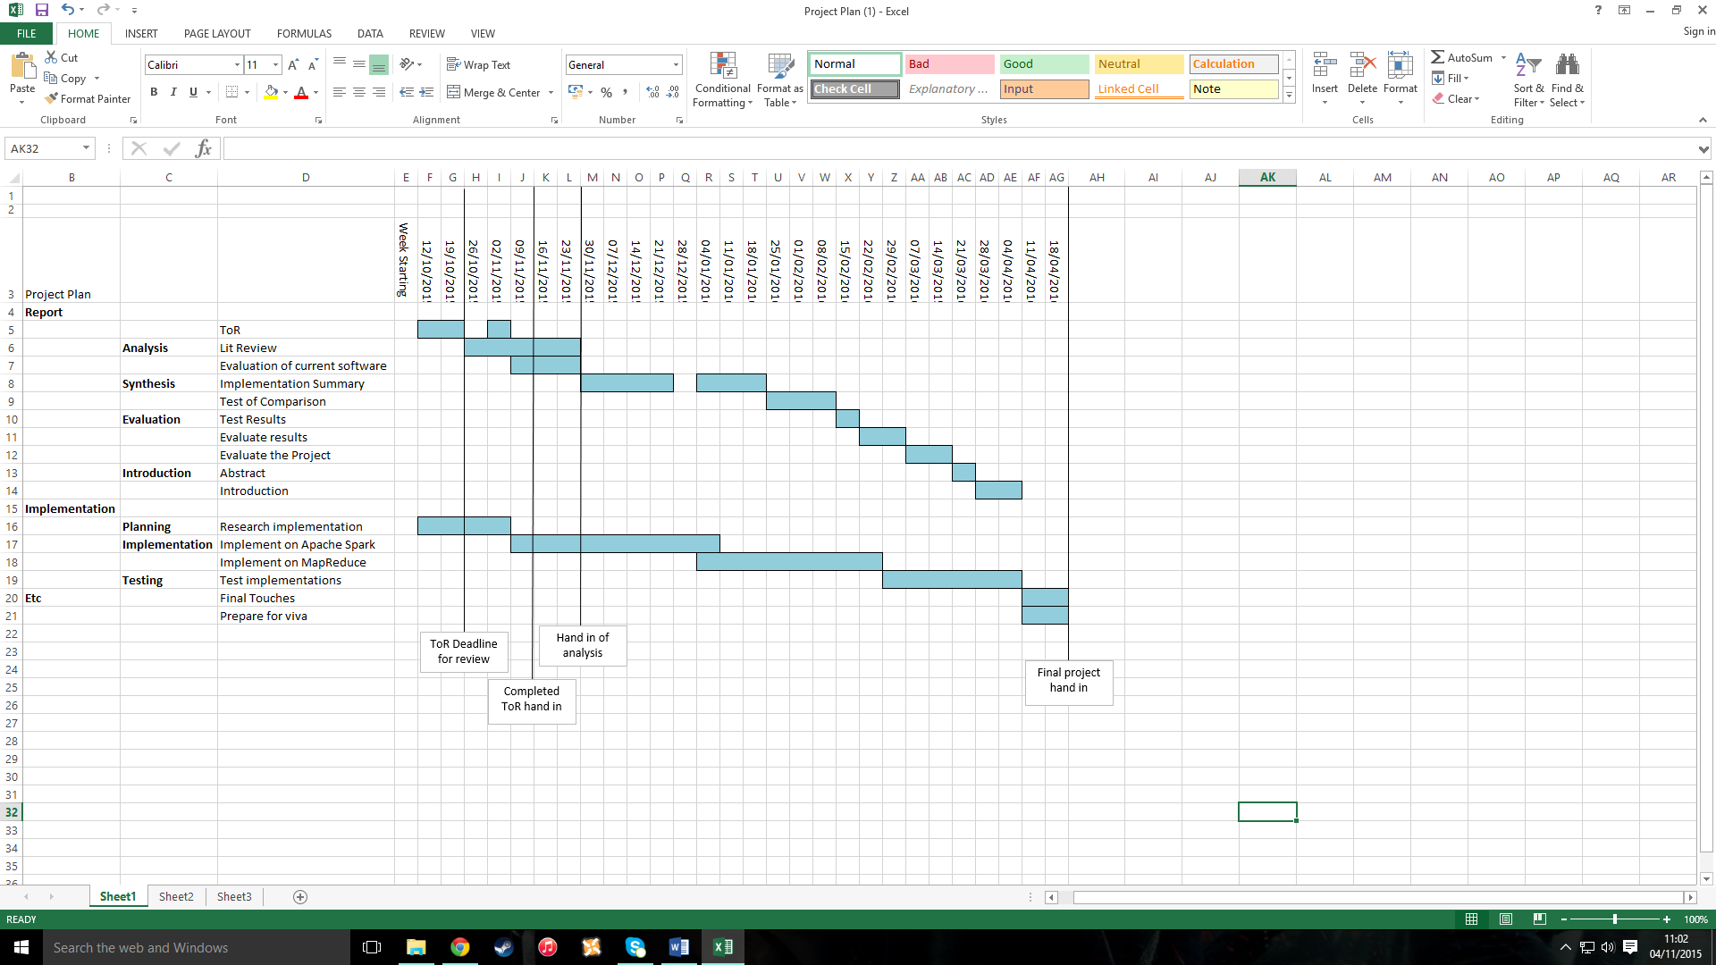

### 9.2 Appendix 2 – Standalone Naïve Bayes algorithm

import numpy as np

from numpy import genfromtxt

import csv

import os

from createDataset import testing, training, dataset, filename

#this function cretes the categories list and populates it with all categories found in the dataset

def getCategories(dataset, noOfAttributes):

i = 0

categories = []

while i < len(dataset):

categories.append(dataset[i, noOfAttributes])

i = i + 1

categories_set = set(categories)

categories = list(categories_set)

return categories

#this function uses the training set to calculate the p_category for each category. This is how many times each category is present in the dataset

def trainData(no_of_test, no_of_category, categories, totalTraining, trainingSet):

no_of_training = 0

no_of_attrib = 0

p_category = 0.0

num_category = 0

while no_of_training < totalTraining:

if categories[no_of_category] == trainingSet[no_of_training][8]:

num_category = num_category + 1

no_of_training = no_of_training + 1

else:

num_category = num_category + 0

no_of_training = no_of_training + 1

p_category = float(num_category) / float(len(trainingSet))

no_of_attrib = no_of_attrib + 1

return p_category, num_category

#this function calculates the probability of each attribute belonging to each category, and then uses that and the previously calculated p_category to give a prediction value.

def calculateProbability(no_of_test, testSet, no_of_attrib, noOfAttributes, trainingSet, p_category, num_category):

no_of_training = 0

count = []

i = 0

count.append(i)

while no_of_training < totalTraining:

if (np.all(testSet[no_of_test, no_of_attrib] == trainingSet[no_of_training, no_of_attrib]) & np.all(categories[no_of_category] == trainingSet[no_of_training, noOfAttributes])):

count[i] = count[i] + 1

no_of_training = no_of_training + 1

else:

no_of_training = no_of_training + 1

p_category *= float(count[i] + 3) / (float(num_category + 3))

return p_category

#this function calculates the accuracy of the predictions made by the algorithm

def getAccuracy(no_of_test, testSet, classifiction, accurate, k):

if (testSet[no_of_test,8] == classification):

accurate[k] = accurate[k] + 1

else:

accurate[k] = accurate[k] + 0

return accurate

trainingSet = training

testSet = testing

#Calculates the number of attributes in the file

with open(filename, 'r') as f:

reader = csv.reader(f, delimiter=',', skipinitialspace=True)

firstRow = next(reader)

noOfColumns = len(firstRow)

noOfAttributes = noOfColumns - 1

#Calculate number of training and test data

totalTraining = len(trainingSet)

totalTest = len(testSet)

cats = getCategories(dataset, noOfAttributes)

categories = [int(v) for v in cats]

length_of_categories = len(categories)

no_of_test = 0

no_of_training = 0

k = 0

accurate = []

accurate.append(k)

p_category = []

#passes all the data to the functions where the calculations are done

while no_of_test < totalTest:

no_of_category = 0

result = []

while no_of_category < length_of_categories:

no_of_attrib = 0

p_category, num_category = trainData(no_of_test, no_of_category, categories, totalTraining, trainingSet)

while no_of_attrib <= noOfAttributes:

p_category = (calculateProbability(no_of_test, testSet, no_of_attrib, noOfAttributes, trainingSet, p_category, num_category))

no_of_attrib = no_of_attrib + 1

#p_categories from each category are saved into the results list to be used later

result.append(p_category)

no_of_category = no_of_category + 1

#the prediction is made by finding the highest p_category value in the results list and its position within the list.

classificationVal = max(result)

classification = float(result.index(max(result)))

stringClass = str(classification)

stringVal = str(classificationVal)

actualResult = float(testSet[no_of_test,8])

stringResult = str(actualResult)

#accuracy is calculated for the prediction

accuracy = getAccuracy(no_of_test, testSet, classification, accurate, k)

text_file = open("MediumNaiveBayesOutput.txt", "a")

text_file.write("(%s, %s) \n" % (stringClass, stringResult))

text_file.close()

no_of_test = no_of_test + 1

#total accuracy of the predictions made is calcuated

totalAccuracy = float(accuracy[k]) / totalTest

print 'Accuracy of Predictions', totalAccuracy

text_file = open("MediumNaiveBayesOutput.txt", "a")

text_file.write("Accuracy: %s." % (totalAccuracy))

text_file.close()

### 9.3 Appendix 3 – Spark Naïve Bayes algorithm

from pySpark.mllib.classification import NaiveBayes, NaiveBayesModel

from pySpark.mllib.linalg import Vectors

from pySpark.mllib.regression import LabeledPoint

from pySpark import SparkContext, SparkConf

import shutil

from shutil import rmtree

import os, tempfile

#sets SparkContext to be used as sc

sc =SparkContext()

#passes in the text file, identifies features and labels from the dataset and returns an RDD with a labeled point

def parseLine(line):

parts = line.split(',')

features = Vectors.dense([float(x) for x in parts[0:7]])

label = float(parts[8])

return LabeledPoint(label, features)

#takes the input text files and maps them using the parseLine function

training = sc.textFile('training.txt').map(parseLine)

test = sc.textFile('testing.txt').map(parseLine)

# Train a Naive Bayes model.

model = NaiveBayes.train(training, 1.0)

# Make predictions using the test data

predictionAndLabel = test.map(lambda p : (model.predict(p.features), p.label))

#Calculates the accuracy of the predictions made

accuracy = 1.0 * predictionAndLabel.filter(lambda (x, v): x == v).count() / test.count()

#print the accuracy of the predictions

print('model accuracy {}'.format(accuracy))

#combine the output into one text file and write results to it

predictionAndLabel.coalesce(1).saveAsTextFile("./Prediction")

### 9.4 Appendix 4 – Dataset Manipulator Script

import numpy

from numpy import genfromtxt

#Read in the file to a numpy array

filename = 'pima-indians-diabetes.data.txt'

dataset = genfromtxt(filename, delimiter=',', dtype=float)

#shuffle the dataset randomly

numpy.random.shuffle(dataset)

#split the dataset into training and testng sets

training, testing = dataset[:460,:], dataset[461:,:]

#output text files containing the training and testing sets

numpy.savetxt('training.txt', training, fmt='%1d', delimiter=',', newline='\n')

numpy.savetxt('testing.txt', testing, fmt='%1d', delimiter=',', newline='\n')

### 9.5 Appendix 5 – Prediction and Accuracy Checker script

#set filename to the standalone output file

standaloneFilename = 'MediumNaiveBayesOutput.txt'

#read in the file, removing any symbols

with open(standaloneFilename) as f:

standalone = f.readlines()

standalone = ([i.strip('(), \n') for i in standalone])

standalone = ([i.replace(',', '') for i in standalone])

#remove the last item in the list, in this case the accuracy print out

standalone.pop()

#split the list into two, one containing the predictions, and one containing the actual categories

std1 = ([i.split(' ')[0] for i in standalone])

std2 = ([i.split(' ')[1] for i in standalone])

#set the filename to the Spark output file

SparkFilename = './Prediction/part-00000'

#read in the file, removing any symbols

with open(SparkFilename) as f:

Spark = f.readlines()

Spark = ([i.strip('(), \n') for i in Spark])

Spark = ([i.replace(',', '') for i in Spark])

#split the list into two, one containing the predictions, and one containing the actual categories

spk1 = ([i.split(' ')[0] for i in Spark])

spk2 = ([i.split(' ')[1] for i in Spark])

#calculate the length of the list

length = len(spk1)

x = 0

same_prediction = 0

#for each item in the Spark list, compare the prediction and actual category. If they match add one to the variable containing the number of same predictions

while x < length:

if ((spk1[x] == std1[x]) & (spk2[x] == std2[x])):

match = True

print match

same_prediction = same_prediction + 1

x = x + 1

else:

match = False

print match

x = x + 1

#write out if each prediction was the same or not to a file

text_file = open("PredictionComparison.txt", "a")

text_file.write("Same Prediction is %s \n" % (match))

text_file.close()

#calculate the percentage of same predictions made

accuracy = float(same_prediction) / length

#write out percentage of same predictions to a text file

text_file = open("PredictionComparison.txt", "a")

text_file.write("Prediction Similarity is %s \n" % (accuracy))

text_file.close()

### 9.6 Appendix 6 – Dataset Manipulator test results on the small dataset

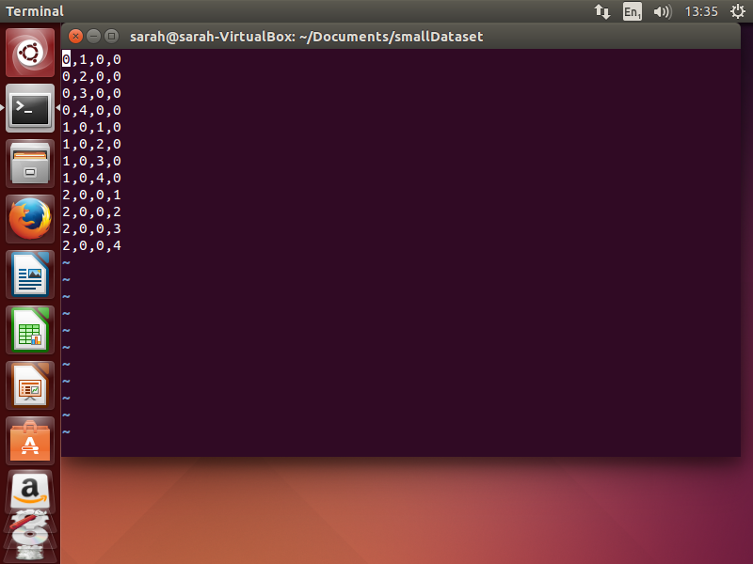

Image 1: The small dataset before manipulation.

Test 1: Test 2: Test 3:

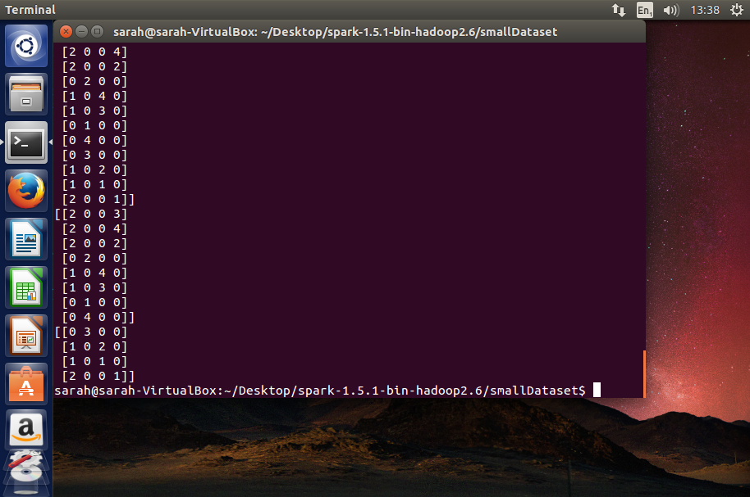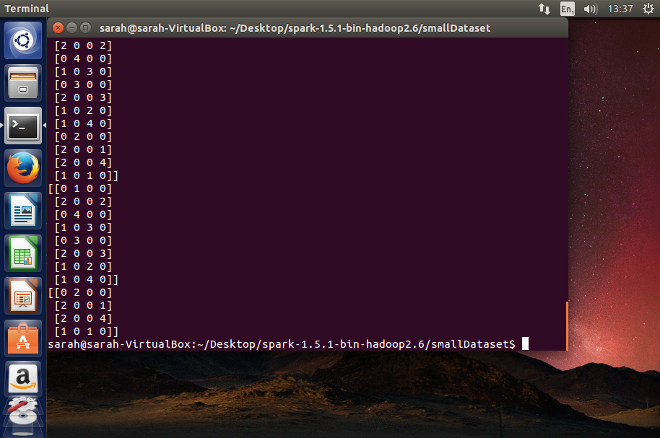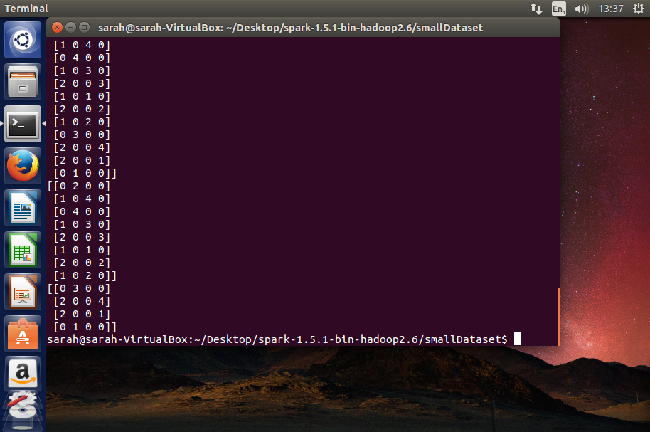

The output training and testing set from each run of the createDataset.py script on the small dataset.

### 9.7 Appendix 7 – Prediction and Accuracy Checker Results

#### 9.7.1 Comparison of Results made by Prediction and Accuracy checker on the Small dataset tests

|  |  |
| --- | --- |
| **Test Number** | **Similarity of Predictions made** |
| 1 | 50% |
| 2 | 50% |
| 3 | 100% |
| 4 | 50% |
| 5 | 50% |
| 6 | 100% |
| 7 | 50% |
| 8 | 100% |
| 9 | 100% |
| 10 | 100% |

#### 9.7.2 Comparison of Results made by Prediction and Accuracy checker on the Medium dataset tests

|  |  |
| --- | --- |
| **Test Number** | **Similarity of Predictions made** |
| 1 | 62% |
| 2 | 62% |
| 3 | 63% |
| 4 | 67% |
| 5 | 64% |
| 6 | 68% |
| 7 | 61% |
| 8 | 68% |
| 9 | 66% |
| 10 | 63% |

#### 9.7.3 Comparison of Results made by Prediction and Accuracy checker on the Large dataset tests

|  |  |
| --- | --- |
| **Test Number** | **Similarity of Predictions made** |
| 1 | 52% |
| 2 | 49% |
| 3 | 50% |
| 4 | 51% |
| 5 | 53% |
| 6 | 48% |
| 7 | 49% |
| 8 | 51% |
| 9 | 50% |
| 10 | 54% |

### 9.8 Appendix 8 – White Box test results on standalone Naïve Bayes

|  |  |  |  |
| --- | --- | --- | --- |
| Test Number | Input | Expected Output | Actual Output |
| 1 | 3,187,70,22,200,36,0,36 | 1 | 1 |
| 2 | 4,156,75,0,0,48,0,32 | 1 | 1 |
| 3 | 3,102,74,0,0,29,0,32 | 0 | 0 |
| 4 | 2,109,92,0,0,42,0,54 | 0 | 0 |
| 5 | 0,161,50,0,0,21,0,65 | 0 | 0 |

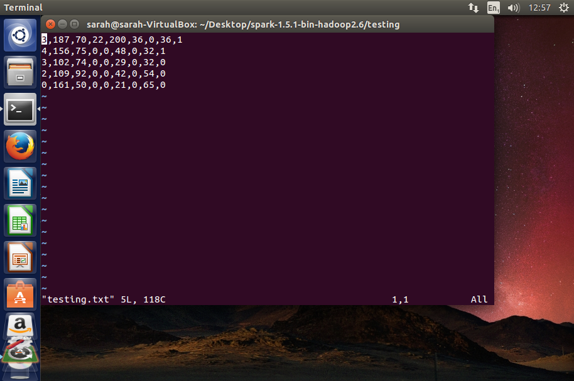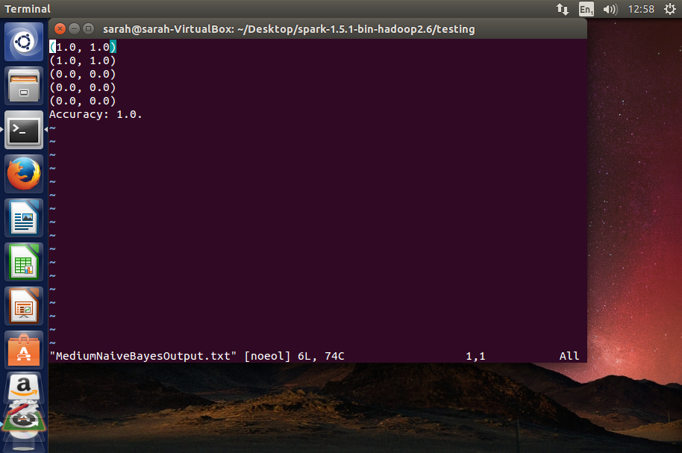Input testing set, taken from testing.txt: Output results, taken from TestingOutput.txt: